Name__________________________________
Triangle Coordinate Geometry Examples Day 2

6. a.) Is ∆PQR isosceles? Why or why not. SHOW MATH! To check congruent sides, __________ ___________.

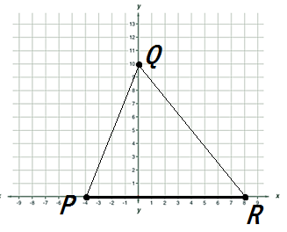

b.) Is ∆PQR isosceles? Why or why not. SHOW MATH! To check congruent sides, __________ ___________.

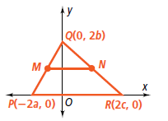

7. M and N are midpoints of QP and QR respectively for ∆PQR. P(-4,0), Q(0,10), and R(8,0). Record your midpoints.
a.) Is ∆MQN a right triangle? Why or why not. SHOW MATH! To check for right angles, __________________.

Record your midpoints.
b.) Is ∆MQN a right triangle? Why or why not. SHOW MATH! To check for right angles, __________________.

8. Determine if ∆TRI is an isosceles triangle if you are given the vertices T(-5,0), R(0,7), and I(5,0).
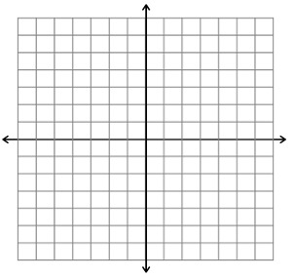

9. Determine if ∆TRI is an isosceles triangle if you are given the vertices below.
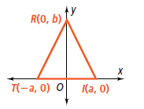

Name______________________________________________ Hour: _______

Practice Triangle Coordinate Geometry Day 2

7. M and N are midpoints of QP and QR respectively.
a.) Find the coordinates of midpoints M and N.
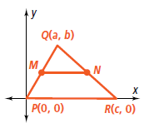

M: ______________ N: _________________

b.) Is MN || PR? Why or why not. SHOW MATH!

c.) Is ∆PQR isosceles? Why or why not. SHOW MATH!

d.) Is ∆PQR a right triangle? Why or why not. SHOW MATH!

8. M and N are midpoints of QP and QR respectively.
a.) Find the coordinates of midpoints M and N.
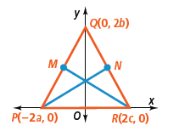

M: ______________ N: _________________

b.) Is ∆PQR isosceles? Why or why not. SHOW MATH!

c.) Is ∆PQR a right triangle? Why or why not. SHOW MATH!

