Coordinate Proofs of Congruent Triangles

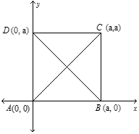1. Given: the Coordinates of Square ABCD

Prove:

2. Given: the Coordinates of Square ABCD

Prove:

3. Given: the Coordinates of Square ABCD

C (2a, 2a)

D (0, 2a)

Prove:

X

B(2a, 0)

4. Given A(0,0), B(2b,2c) and C(4b,0) and M and N are the midpoints of AB and BC respectively.

Prove: ∆MCA ∆NAC

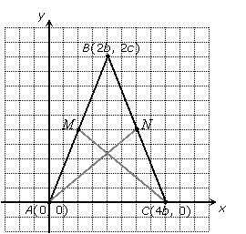

5. Given: and the coordinates of the vertices

Prove:

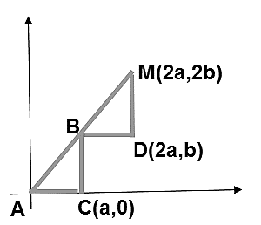

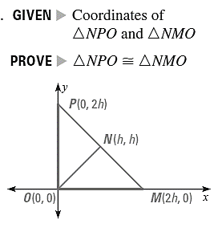

6.

7. Given: the coordinates of figure PTRA

Prove: $∆PTR≅∆ART$

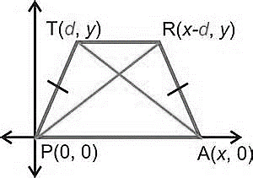

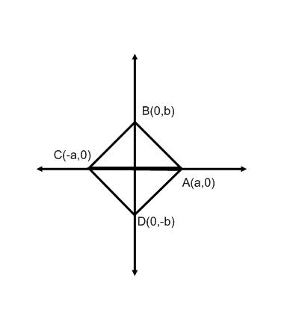8. Given: the coordinates of $∆AXB$ and $∆CXD$

Prove: $∆AXB≅∆CXD$

X