Basic Surface Area and Volume of Prisms and Cylinders- Notes

Surface Area: | Lateral Area: | Volume:
Example1:
Find the volume, lateral area and surface area of the prism.

Practice Example: Find the volume, lateral area and surface area of the prism.
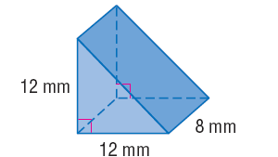
1.

Cylinders:
Surface Area: | Lateral Area: | Volume:

Example2:
Find the volume, lateral area and surface area of the prism.
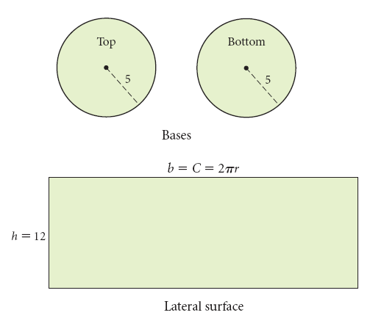
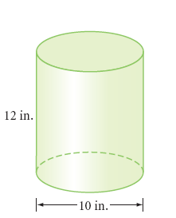

Practice Examples: Find the volume, lateral area and surface area of the solid.
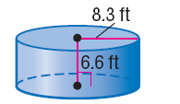
1.

Basic Surface Area and Volume of Prisms and Cylinders- In-Class Practice
Directions: Find the volume and surface area of the solid, round to the nearest tenth if needed.

1.

2.

3.

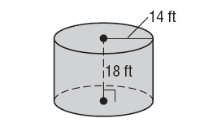
4.

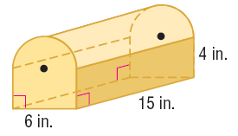
5.

Name: _______________________________________________________Hour: ___________________
Basic Surface Area and Volume of Prisms and Cylinders- Homework
Directions: Find the volume and surface area of the solid, round to the nearest tenth if needed.
1.

2.

3.

4.

5.

6.

7.

8.

