Basic Surface Area and Volume of Pyramids and Cones- Notes
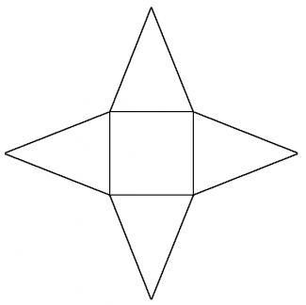
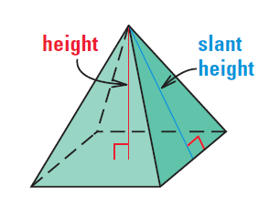
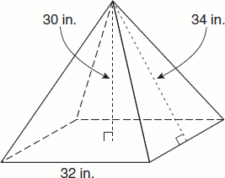

Surface Area: | Lateral Area: | Volume:
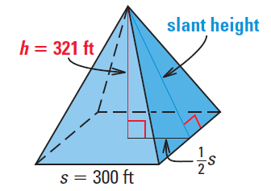
Find the volume and surface area of the solid. Round to the nearest tenth.
Example1:

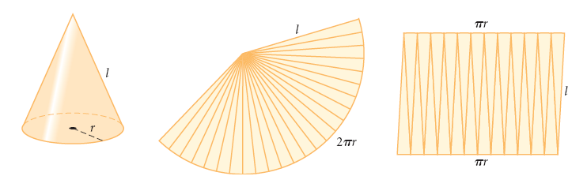
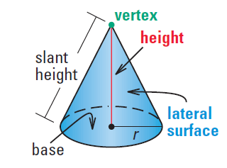

Example 2:
Find the volume and surface area of the solid. Round to the nearest tenth.
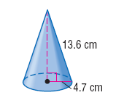
Surface Area: | Volume:

Example 3:
Find the volume and surface area of the solid. Round to the nearest tenth.

Surface Area: | Volume:
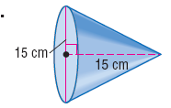

Find the volume and surface area of the composite solid.

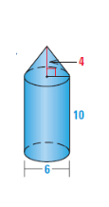

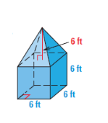

Basic Surface Area and Volume of Pyramids and Cones- In-Class Practice
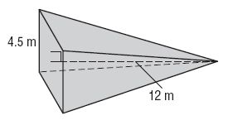
Find the volume and surface area of the solid. Round to the nearest tenth.
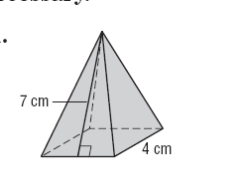

1. 2.

3. 4.

5. 6.

7.

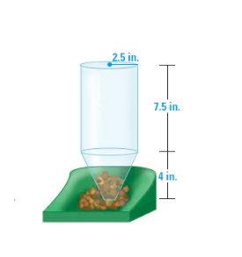

Name: _____________________________________________Hour: _______
Basic Surface Area and Volume of Pyramids and Cones
Homework
Find the volume and surface area of the solid. Round to the nearest tenth.
1. 2.

3. 4.

5. 6.

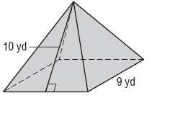
7. 8.

9. 10.

11. 12.

13. 14.

