Distance and Midpoint Homework #1
Directions: Use the Pythagorean Theorem or Distance Formula to find the distance of each segment, and then find the midpoint of each segment. You must simplify radicals and fractions – no decimals!!!!

1. G(2,6), H(-1,4) Distance: __________
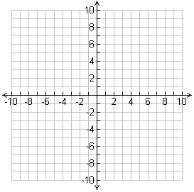
Midpoint:___________

Slope: _____________

2. J(7,10), K(-4,5) Distance: __________
Midpoint:___________

Slope: _____________

3. D(0,2), E(4,5) Distance: __________

Midpoint:___________

Slope: _____________

Directions: M is the midpoint of $\overline{XY}$. Find the missing endpoint’s coordinates based on the given information.

4. M(2,3), X(-1,5) Find Y(x,y)

5. M(3,1), Y(-4,7) Find X(x,y).

Use figure to the left for 6-8.
In this figure,$\overline{GE}$ bisects $\overline{BC}$ and $\overline{GF}$ bisects $\overline{AB}$. $\overline{FG}⊥\overline{GE}.$
6. Find the coordinates of F, E and G. F: ______
E: _______

G: _______

7. Find the following lengths by calculating the distance between each endpoint.

AB=___________ BE=___________

BC=___________ BF=___________

CD=___________ BG=___________

BD=___________ DG=___________

8. Name conclusions or relationships that you can conclude based on the information you found in #6 and 7. It must be based on what YOU found, NOT what was given to you.

