Distance and Midpoint Homework #2
Directions: Use the Pythagorean Theorem or Distance
Formula to find the distance of each segment, and then
find the midpoint of each segment. You must simplify radicals and fractions!!!!

1. G(-3,2), H(6,5) Distance: __________
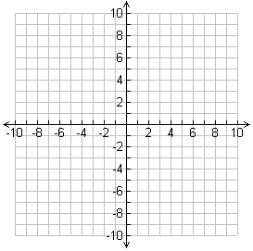
Midpoint:___________

Slope: _____________

2. J(-2,-2), K(3,4) Distance: __________
Midpoint:___________

Slope: _____________

3. D(-5,3), E(1,5) Distance: __________

Midpoint:___________

Slope: _____________

Directions: M is the midpoint of $\overline{XY}$. Find the missing endpoint’s coordinates based on the given information.

4. M(-10,-3), X(-9,-2) Find Y(x,y)

5. M(6,-2), Y(4,2) Find X(x,y).

For the next two questions, use the map where one unit on the grid corresponds to 100 yards.
6. Ben asks Katie to meet him after school. He would like to ask her on a date. He decides to meet her half way to ask her. What is the halfway point where Ben will ask her out?

7. Katie says “YES!”. Ben is planning to pick her up. What is the distance he will need to travel in order to get to her house?

