Distance and Midpoint Practice
Directions: Use the Pythagorean Theorem or Distance Formula to find the distance of each segment, find the slope of each line through the points, and then find the midpoint of each segment. You must simplify radicals and fractions!!!!

1. G(-2,-6), H(6,9) Distance: __________
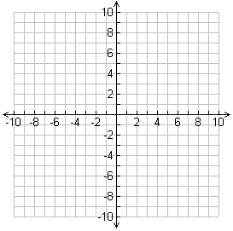
Midpoint:___________

Slope: _____________

2. J(-3,4), K(2,-4) Distance: __________
Midpoint:___________

Slope: _____________

3. D(2,0), E(8,6) Distance: __________

Midpoint:___________

Slope: _____________

Directions: M is the midpoint of $\overline{XY}$. Find the missing endpoint’s coordinates based on the given information.

4. M(-1,5), X(-4,3) Find Y(x,y)

5. M(-2,2), Y(2,8) Find X(x,y).

6. Scout Troop 175 is designing their new campground by first mapping everything on a coordinate grid. They have found a location for the mess hall and for their cabins. They want the bathrooms to be halfway between these two. What will the coordinates of the location of the bathrooms?

7. Describe a way to divide a segment into fourths.

8. Explain how the distance formula and Pythagorean Theorem are related.

