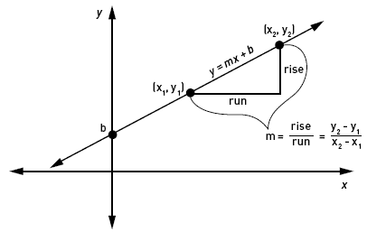
Distance, Midpoint & Slope Instruction
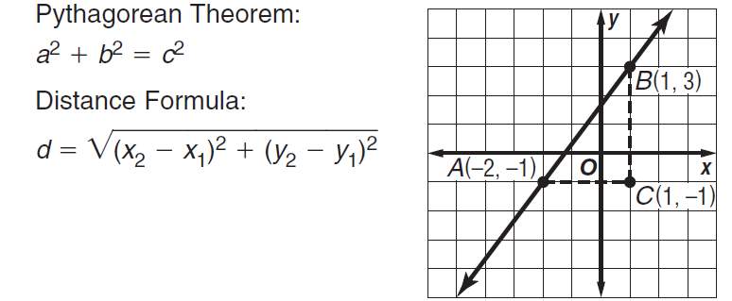
Slope:

Let’s Practice!
Directions: Use the Pythagorean Theorem or Distance Formula to find the distance of each then find the slope.
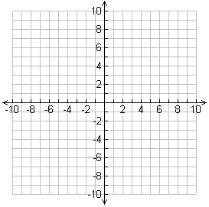
Ex 1. L (-2, -3), M (4, 0)

Directions: M is the midpoint of $\overline{AB}$. Find the missing coordinates based on the given information.

EX2. M(-1,6), B(2,8) Find A(x,y). EX3. M(-5,10), A(-8,6) Find B(x,y)

Pg. 55 #20-23
Find the perimeter and area of each figure with the given verticies.
20.) D(-2,-2), E(-2,3), and F(2,-1) 21.) J(-3,-3), K(3,2), and L(3,-3)

22.) P(-1,1), Q(3,4), R(6,0) and S(2,-3) 23.) T(-2,3), U(1,6), V(5,2),
and W(2,-1)

