Name: __________________________________________________________ Date: _____________
Dog on a leash- Real World

Part A in the picture below:
On a nice day, Millie, Ms. Schmidt’s goldendoodle dog, loves to go outside to run! Point A is the place where her leash is anchored to the rectangular barn so that she can play outside. Find the maximum area the leash will allow her to play if her leash is 28ft long. Keep answer in terms of pi.

35 ft
A

20 ft

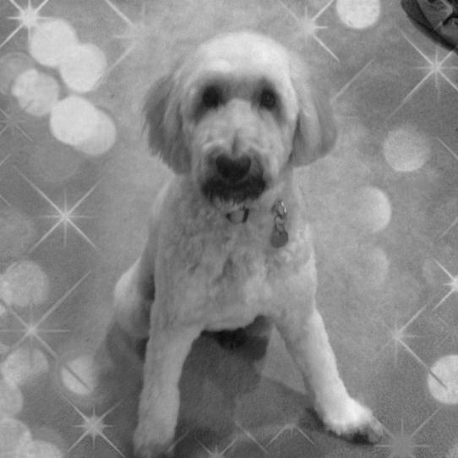

Part B in the picture below:
Millie still wants to be outside even on a day which is gloomy and could rain! Point B is the place where her leash is anchored to the rectangular barn so that she can play outside but still get in the barn if it does start to rain. Millie can find shelter in the barn which has an opening of 5 ft. Find the maximum area the leash will allow her to play if her leash is 28ft long including the area inside the barn. Keep answer in terms of pi.

35 ft

Opening
5 ft
20 ft

13 ft

10 ft
B

