Equations and Graphs of Parallel and Perpendicular Lines: Homework
For the following graphs, a) write the equation of the line given, b) draw a parallel line, and c) give the equation of the line your drew.
a)______________________ a)______________________
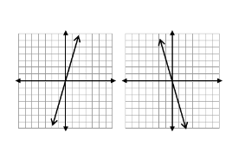
b) on graph b) on graph
c)_____________________ c)______________________

For the following graphs, a) write the equation of the line given, b) draw a perpendicular line, and c) give the equation of the line your drew.
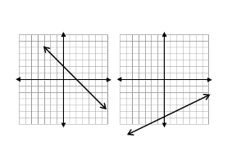
a)______________________ a)______________________
b) on graph b) on graph
c)_____________________ c)______________________

For the following graphs, a) write the equation of the line given, b) draw a parallel line, and c) give the equation of the line your drew.
a)______________________ a)______________________
b) on graph b) on graph
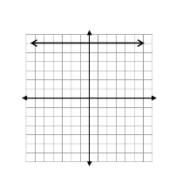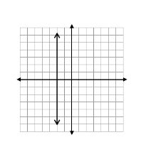c)_____________________ c)______________________

For the following graphs, a) write the equation of the line given, b) draw a perpendicular line, and c) give the equation of the line your drew.(Hint: The graphs given are the same as those above.)
a)______________________ a)______________________
b) on graph b) on graph
c)_____________________ c)______________________

