Name: ___________________________________________________________________________
Final Exam Prep Individual Practice

Area Exercises
Directions: Show answers in terms of PI, then round your answers.
1. A $4$-centimeter by $3$-centimeter rectangle is inscribed in a circle. What is the area of the circle, in square centimeters?
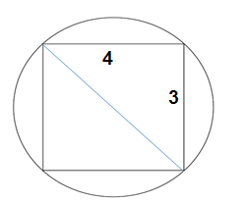

2. A $12$-centimeter by $7$-centimeter rectangle is inscribed in a circle. What is the area of the circle, in square centimeters?
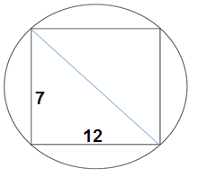

3. Find the area of a circle with a circumference of $42π.$

4. Find the area of a circle with a circumference of $30π.$

5. Find the area of a circle with a circumference of $80π.$

6. Find the area of a circle with a circumference of $10π.$

7. Find the area of the regular hexagon. Radius = 10 in
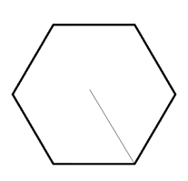

8. Find the area of the regular hexagon. Radius = 18 cm

9. In the standard $(x, y)$ coordinate plane below, the points $\left(0,3\right), \left(1,5\right), \left(4,5\right),$ and $(3,3)$ are the vertices of a parallelogram. What is the area, in square units, of the parallelogram?

10. In the standard $(x, y)$ coordinate plane below, the points $\left(2,5\right), \left(8,5\right), \left(7,1\right),$ and $(1,1)$ are the vertices of a parallelogram. What is the area, in square units, of the parallelogram?

11. Paul wants to carpet the floors in his living room (rectangle) and his bedroom (trapezoid). Find the area needed to carpet.
