Name: ______________________________________________________________________

Final Exam Prep Practice

Surface Area Examples

1. The bottomless tent illustrated below is in the shape of a right triangular prism and is made of nylon. How many square feet of nylon is required for the front, rear, and $2$ sides of the tent?
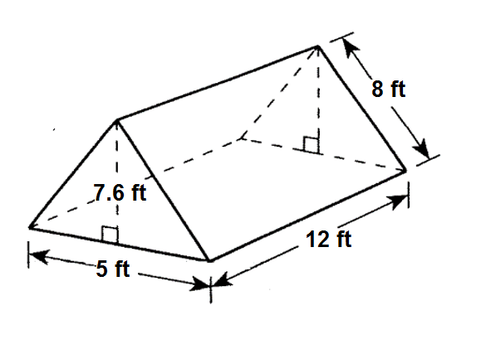

2. Find the amount of canvas required for the sides, floor, front, and rear of the tent in the shape of a triangular prism as shown in the figure. The base of the prism is an isosceles triangle with sides 200 centimeters each.
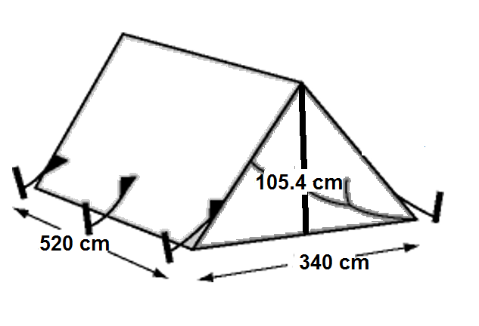

3. The diagram below is a sketch for the casing for a firecracker that has a height of $4$-meters and the base is a square. Ignoring overlap between faces of the casing, what is the amount of cardboard needed to create the casing (surface area), in square meters?
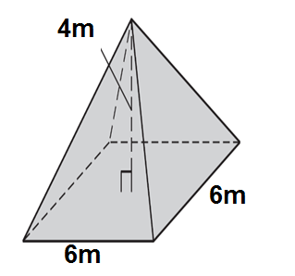

4. Extra Area Practice: If the information is given in centimeters, find the area of the shaded region.
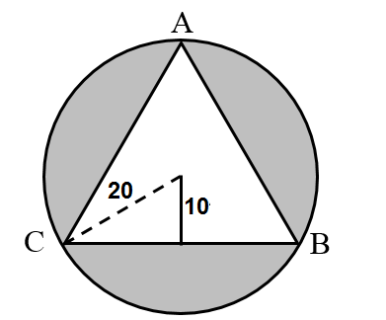

5. The length of arc $XY$ of a circle is equal to $\frac{1}{8}$ of the circumference of the circle. The length of the arc is $5π$ inches. Find the central angle of the circle, in degrees. Find the radius, in inches, and then use that radius to find the area of the shaded sector, in square inches. If needed, round any answer to the nearest tenth.
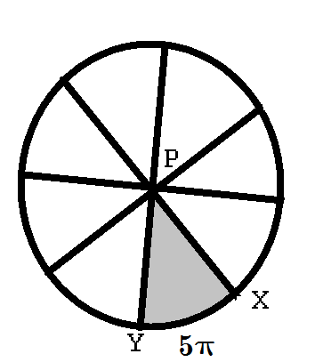

Central Angle ∠XPY= _________

Radius = _________

Sector Area =_________

6. The length of arc $XY$ of a circle is equal to $\frac{1}{6}$ of the circumference of the circle. The length of the arc is $12π$ inches. Find the central angle of the circle, in degrees. Find the radius, in inches, and then use that radius to find the area of the shaded sector, in square inches. If needed, round any answer to the nearest tenth.

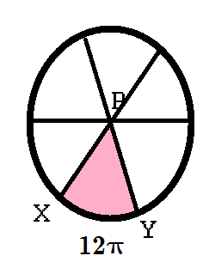
Central Angle ∠XPY= _________

Radius = _________

Sector Area =_________

