Name: ___________________________________________________________

Final Exam Prep Practice

Triangles Unit Exercises
Directions: Round to the nearest tenth if needed.
1. Find x.
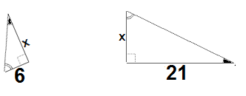

2. If $∆ABC\sim ∆PQR$, find the perimeter of $∆PQR$.
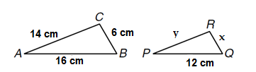

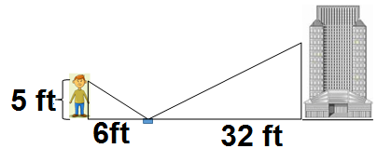
3. Ryan places a mirror on the ground between himself and his office building. He stands so that he can see the top window on the 19th floor. The mirror is 6ft from his feet and 32 ft from the base of the office building. Ryan’s eyes are 5 ft above the ground. How high is the window when rounding, in meters, to the nearest tenth?

4. A kite is caught in a tree. The string of the kite is 92 ft long, and the base of the string is on the ground 75 ft away from the base of the tree. How high up is the the kite at the top of the tree?
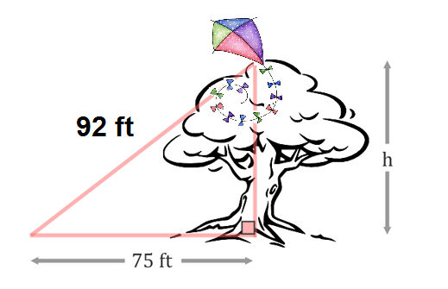

5. Find x. 6. Find c.
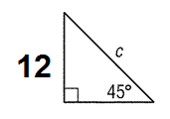
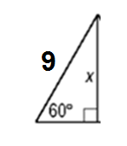

7. If a triangle has the side lengths of 13, 5, 12 does it form a right triangle? Why or why not?

8. Find Sin A, Cos B, and Tan A. (show as fractions-SIMPLIFY!)

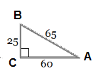

9. Find x. 10. Find the height of the lamp post. 11. Find x.

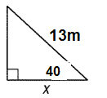
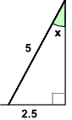
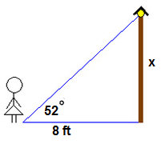

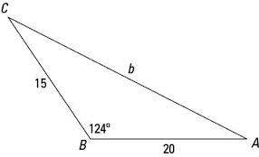
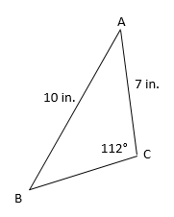
12. Find <B. 13. Find b.

