Name: _____________________________________ Hour: _________
Similar Right Triangles Day 1 Homework

Directions:
a.)Draw out the 3 triangles and color code to help find all of the missing variables.
b.)In each problem, find the missing length(s) that are indicated.
c.) Leave your answer in SIMPLEST RADICAL FORM!

1.

2.

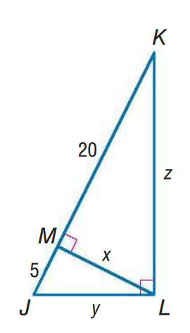
3.

4.

