Geometric Mean Homework #2
Directions: Determine if the following sides form right triangles. Then state if they form a Pythagorean Triple.
1 30, 40, 50 2. 20, 30, 40 3. 18, 24, 30

4. $\frac{3}{7},\frac{4}{7},\frac{5}{7}$ 5. 9, 40, 41 6. $2, \sqrt{8}, \sqrt{12}$

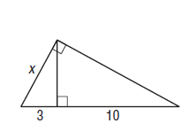
Directions: Find x, y, and z for the following.
7.

8.

9.

10.

