Name: ___________________________________________________ Date: _____________
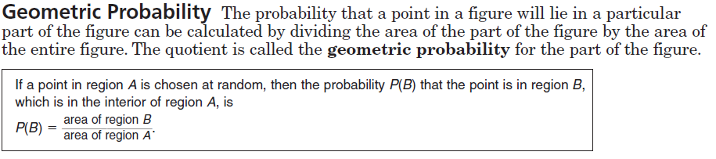
Geometric Probability Day #2- notes

Find the area of both regions and then find the probability that a point chosen at random lies in the shaded region. Round your answers to the nearest tenth.
Examples:
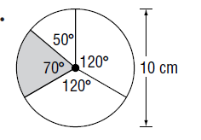
1.

2.

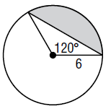
3.

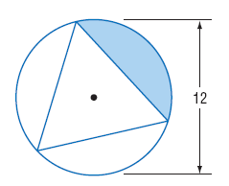

4.

5.

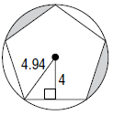
6.

Name: ___________________________________________________ Date: _____________
Geometric Probability Day #2- HW
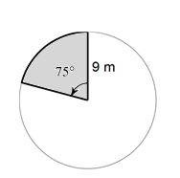
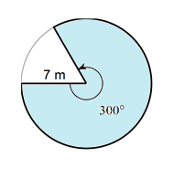
Find the area of both regions and then find the probability that a point chosen at random lies in the shaded region. Round your answers to the nearest tenth.
1. 2.

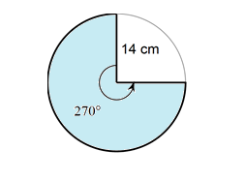
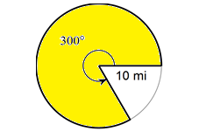
3. 4.

5. 6.

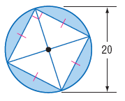
7. 8.

Name: ___________________________________________________ Date: _____________
Geometric Probability Check Point A
Find the area of both regions and then find the probability that a point chosen at random lies in the shaded region. Round your answers to the nearest tenth.
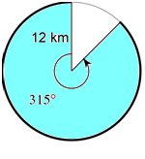
1.

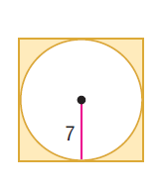

2.
15

Name: ___________________________________________________ Date: _____________
Geometric Probability Check Point B
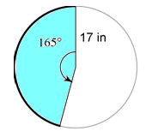
Find the area of both regions and then find the probability that a point chosen at random lies in the shaded region. Round your answers to the nearest tenth.
1.

2.

