ACC Notes

Name: ___________________________________________________ Date: _____________

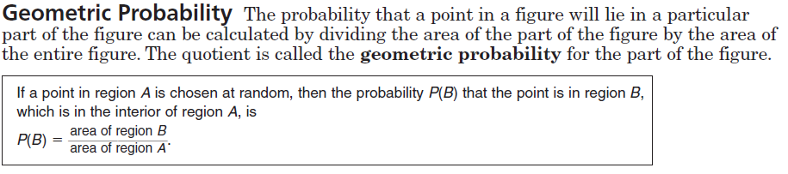

Find the probability that a point chosen at random lies in the shaded region. Round your answers to the nearest tenth.

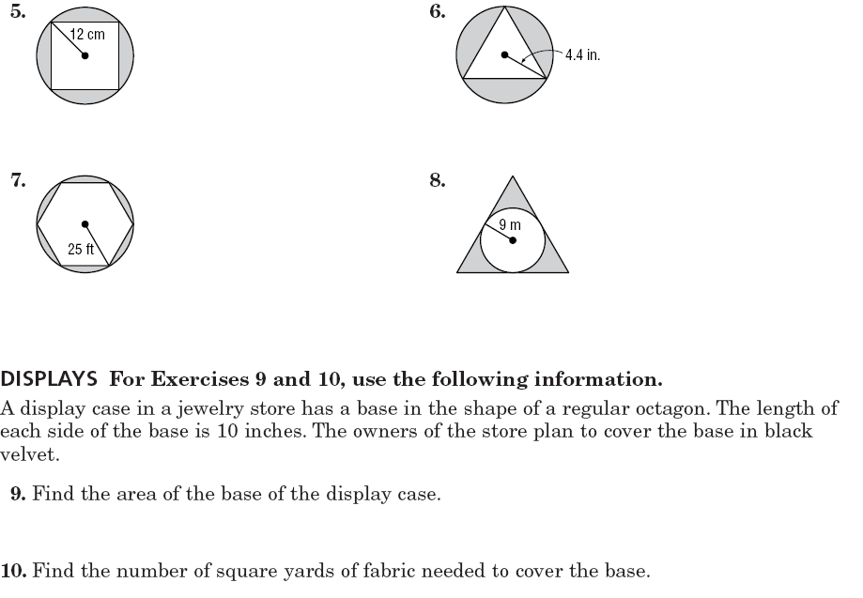

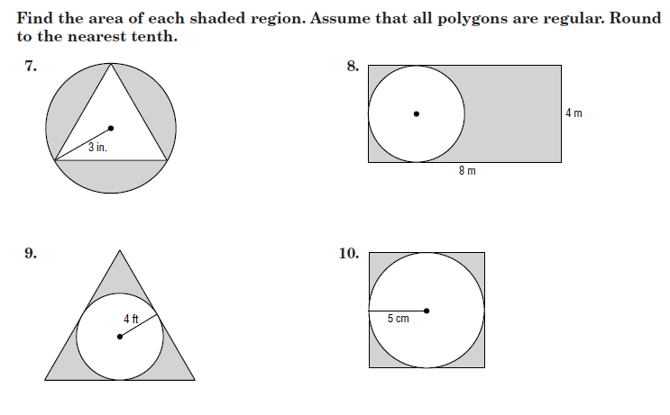1. 2.

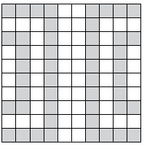3.

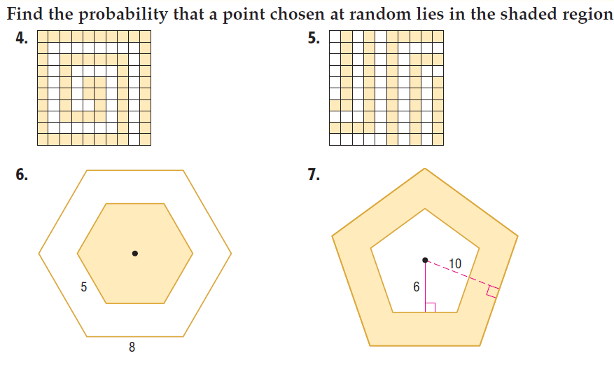4.

8

5. A target has a central circle and three concentric circles. The diameters of the circles are 2 cm, 6 cm, 10 cm, and 14 cm. Find the probability of landing in the BLUE region.

G

B

R

Y

**ACC Geometric Probability Homework #1**

Find the probability that a point chosen at random lies in the shaded region. Round your answers to the nearest tenth.

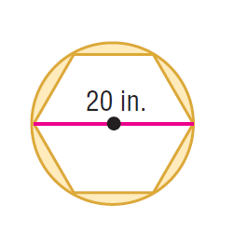

10km

1. 2.

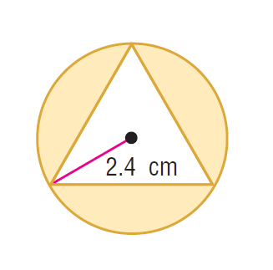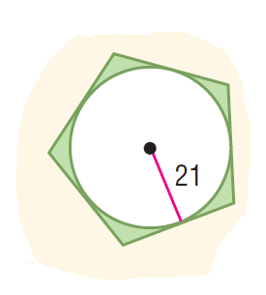

3. 4.

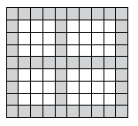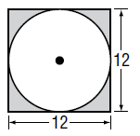

5. 6.

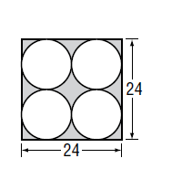7. 8. Apothems are 6 and 10.



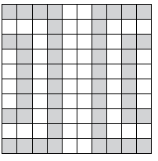

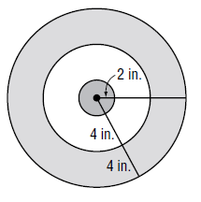9. 10.

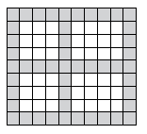

11. 12. Use the squares below.

22 cm

**18 cm**

13. 14. Diameter= 642m

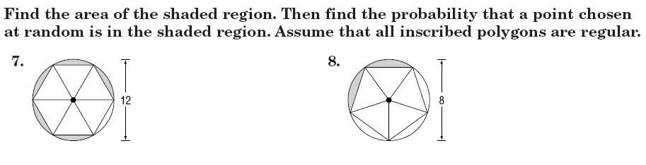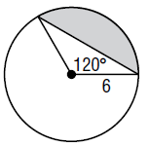15. 16.

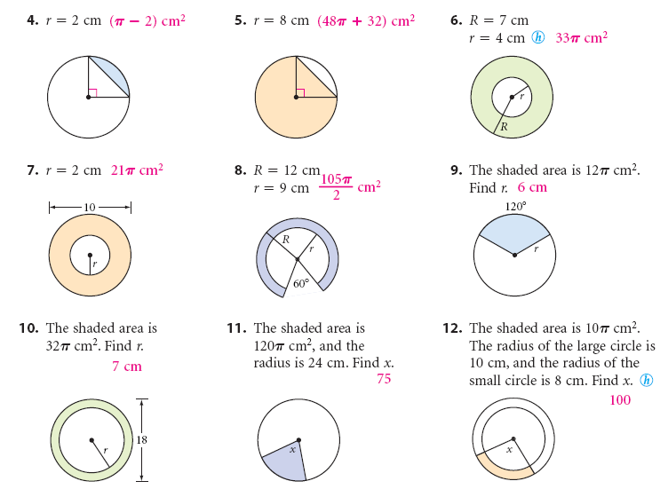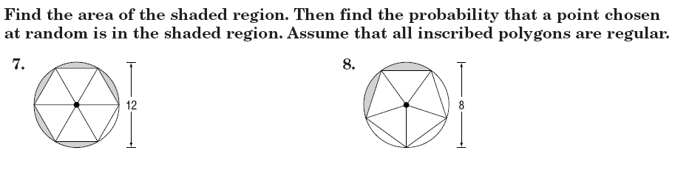17. 18. R= 8 cm



19. 20.