ACC Geometric Probability Review/Warm-up
Find the area and the probability that a point chosen at random lies in the shaded area. Round to nearest tenth. Not drawn to scale.
1. Use the squares below. 2.
22 cm

What is the area of the white region?
What is the probability of choosing at random a space in the shaded region?
3. 4. ( all units are inches- some wwere cut off on picture)
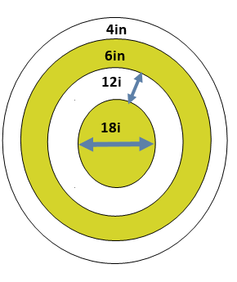

Find the area and the probability that a point chosen at random lies in the shaded area. Round to nearest tenth. Not drawn to scale.
5.
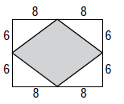
$\frac{Area of shaded}{Area of Total}=$

6.

7. Red 9. Blue

8. Gold 10. Yellow

Find the area of the shaded region and the probability that a point chosen at random lies in the shaded region, assume all inscribed polygons are regular. Round to the nearest tenth.
11. 12.

