Name: _______________________________________________________________

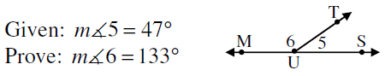**Geometry Proofs Worksheet B**

1.

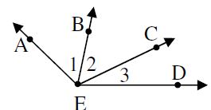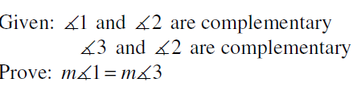

2.

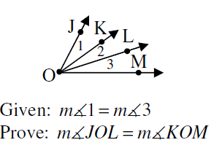

3.

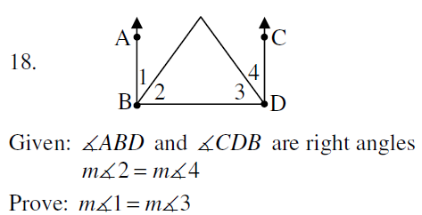

4.

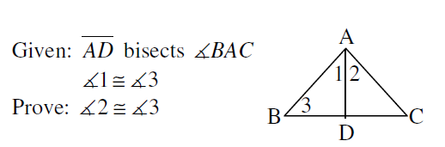

5.

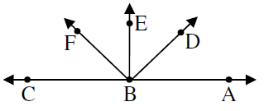

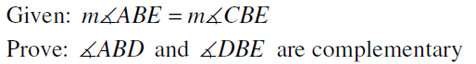6.