Golden Ratio Activity
Directions: In groups, measure your height and your belly button height in centimeters.
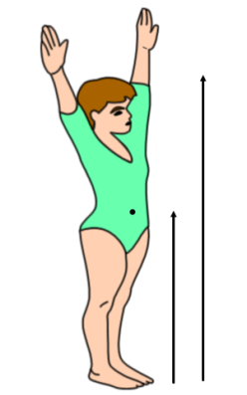
Height (cm)
Belly Button Height (cm)

Directions: Divide your height by your belly button height. (Round to the nearest ten-thousandth.)

Your Height =
Your Belly Button Height

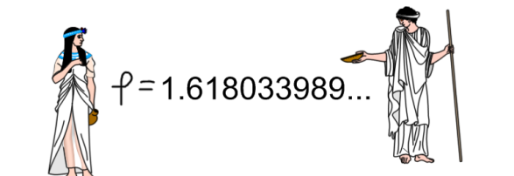
The Greeks believed in the “Golden Ratio”- that a god or goddess had a ratio of

when comparing height to belly button height.

Are you considered a Greek god or goddess in mythology?_______________

Directions: Now, figure out how tall you would have to be (desired height) in order to be a considered Greek god or goddess in mythology. (Solve for x.)

Your Desired Height (x) = 1.618033989...
Your Belly Button Height

X = _________________

