Individual Practice:
Basic Constructions of Rotations and Reflections

Reflect the given figure over the given line.

1.

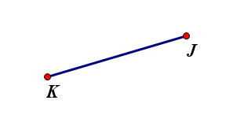

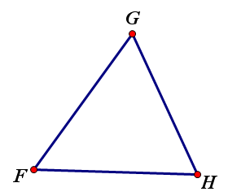

2.

Rotate the given figures around the point of rotation, point R.

3. Rotate 120° counterclockwise

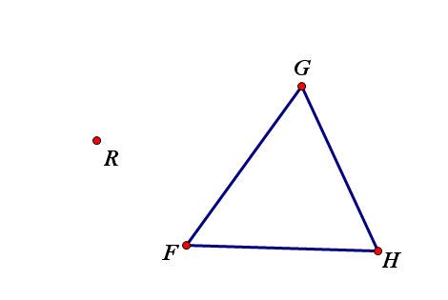

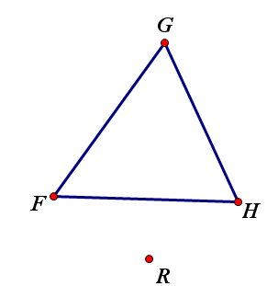
4. Rotate 170° clockwise.

