Interesting Bases Group1:
Directions: Find the volume.

Interesting Bases Group 2:
Directions: Find the surface area.

Interesting Bases Group 3:
Directions: Find the surface area.
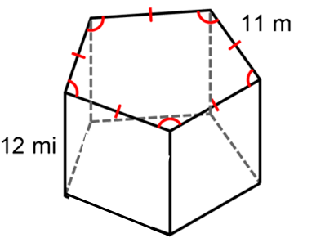

Interesting Bases Group 4:
Directions: Find the surface area.
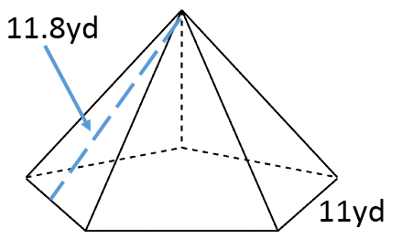

Interesting Bases Group 5:
Directions: Find the volume.

Interesting Bases Group 6:
Directions: Find the volume.
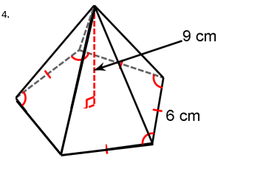

Interesting Bases Group 7:
Directions: Find the volume.
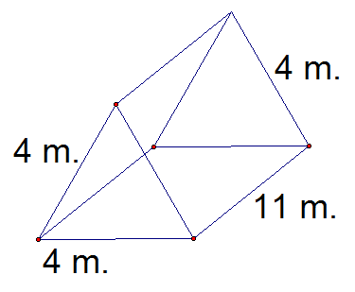

Interesting Bases Group 8:
Directions: Find the surface area.

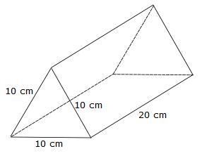

Name(s): _________________________________________________________________________________________

_________________________________________________________________________________________________
Interesting Bases Group Assignment
Show all work and final answers in this assignment sheet. Failure to show work will result in ALL students in the group earning no credit for the question. At your table, you are responsible for ALL students to participate. If you feel others are not participating, you will need to discuss it with the student.
Group 1:

Group 1: _______________________________
-----------------------------------------------------------------------------------------------------------------------------
Group 2:

Group 2: _______________________________
-----------------------------------------------------------------------------------------------------------------------------
Group 3:

Group 3: _______________________________
-----------------------------------------------------------------------------------------------------------------------------
Group 4:

Group 4: _______________________________
Group 5:

Group 5: _______________________________
-----------------------------------------------------------------------------------------------------------------------------
Group 6:

Group 6: _______________________________
-----------------------------------------------------------------------------------------------------------------------------
Group 7:

Group 7: _______________________________
-----------------------------------------------------------------------------------------------------------------------------
Group 8:

Group 8: _______________________________

