Name: _________________________________________________________________
SA and Volume with Interesting Bases In-Class Practice

Warm-up Question- Find the Surface area and volume of the following figures.
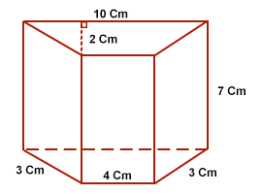
A)

B)

Individual Practice/Review
Directions: Find the surface area and volume for the following prism.
1. SA= ___________________

V= ____________________

Directions: Find the surface area and volume for the following pyramids.
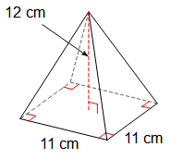
2.a) b)

SA= _______________ V= _________________ SA= _______________ V= _________________

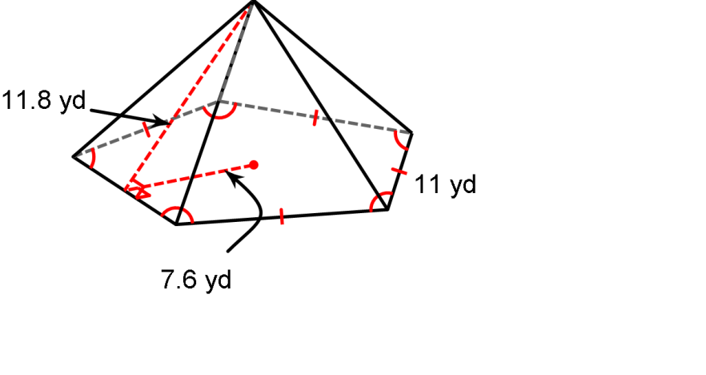
Directions: Find the surface area for the following pyramid.
3. SA= ___________________

Directions: Find the volume for the following pyramid.
4.
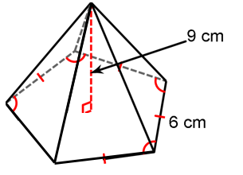
V= ____________________

Can be done at home if needed.
5. Find the surface area and volume.

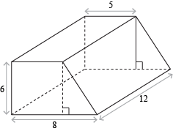
6.

More on next page…
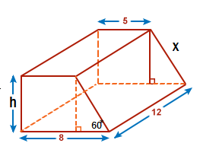
7.

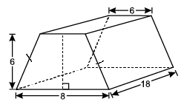

8.

