Name: _______________________________________________ Date: _____________ Hour: __________
To study for my “Interesting Bases QUIZ” I did the following: ________________________________
_________________________________________________________________________________________
__________________________________________________________________________________________
It is your responsibility to retake the Interesting Bases Quiz if you need to. Do this in a timely fashion. You MUST make corrections on your quiz and complete this intervention correctly before the retake.
Interesting Bases Intervention:
Directions: Find the surface area and volume for the following prism.
1. SA= ___________________

V= ____________________

Directions: Find the surface area and volume for the following pyramid.
2. SA= ___________________

V= ____________________

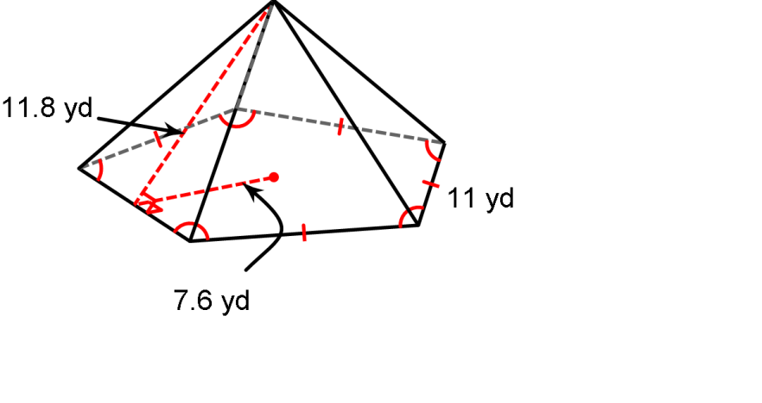
Directions: Find the surface area for the following pyramid.
3. SA= ___________________

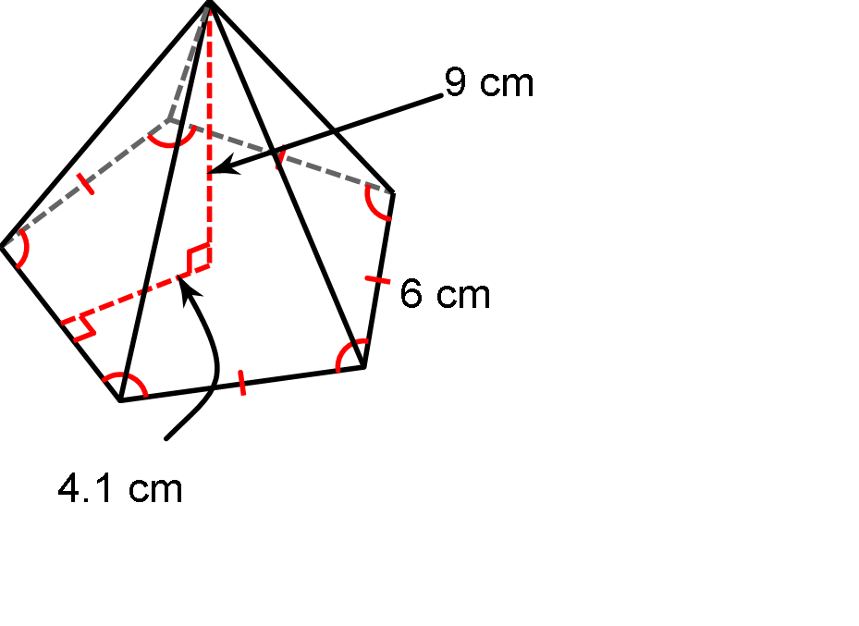
Directions: Find the volume for the following pyramid.
4.
V= ____________________

