Recalling Area- Notes

When finding the area of a polygon, the units must be included and they must be _________ ___________.

Let’s look at some formulas!

Parallelogram: Triangle:

Trapezoid: Circle:

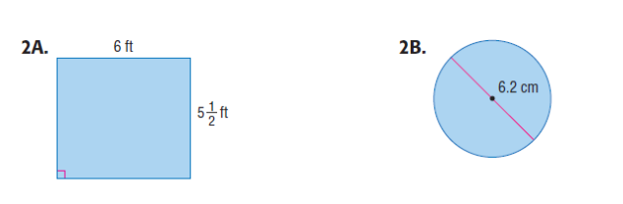

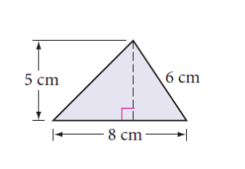**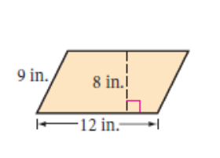Examples:** Find the area of the following figures.

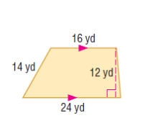

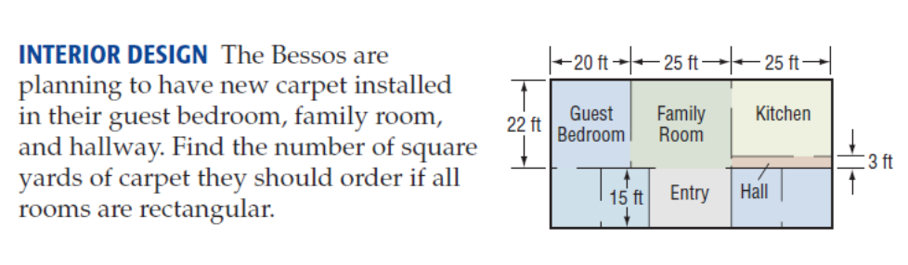



Guest Bedroom:

Family Room:

Hallway:

**Area: Missing Sides + Recall of Special Right Triangles Notes**

Find the area of the following figures.

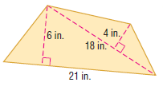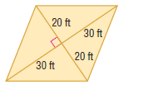1. 2.

Find the area. (Use special right triangles)

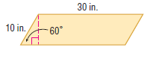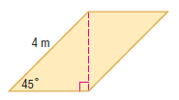3. 4.

Find a missing length.

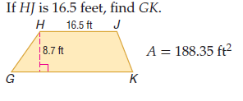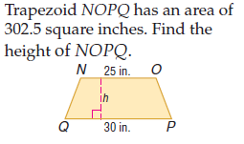5. 6.

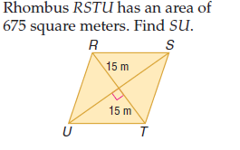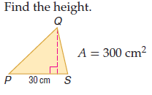7. 8.

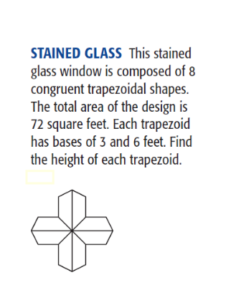

9.

Name: _____________________________________ Date: __________

Recalling Area, Finding Missing Length Figures Homework

Find the area of each figure.

1. 2.



3. 4. 



5. 6. 



7. 8.



9. 10.

11. 12. 

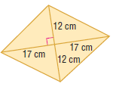

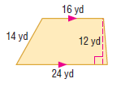13. 14.

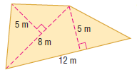

15.

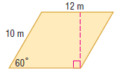For #16 and 17, find the area using special right triangles.

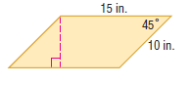16. 17.

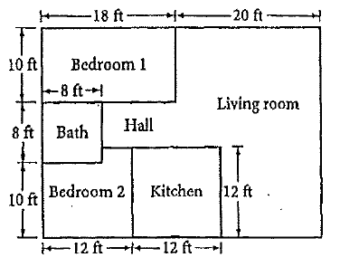18. The Sibleys are tiling their kitchen and bathroom. Find the area of the bathroom and kitchen. If each tile is 6 inches by 6 inches, how many tiles will the Sibleys need?

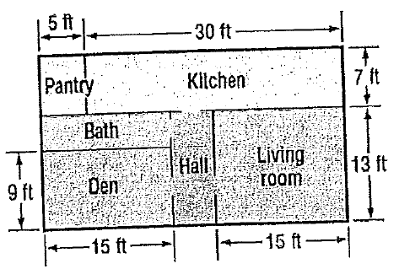

19. The Smiths are planning to carpet part of their house. The carpet they plan to buy is sold by the square yard. Find the amount of carpeting needed to cover the living room, den, and hall if all are rectangular rooms. (3 ft = 1 yd)

For #20-21, find a missing length.

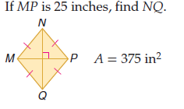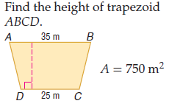20. 21.

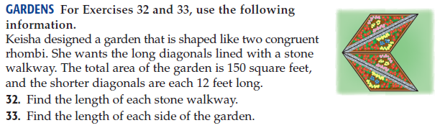22.