Isosceles and Equilateral Triangles- Homework
Directions: Show all work to find x. Circle your final answer.

1. 2.

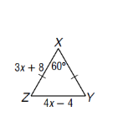

3. 4.

5.

m<1 = ______
m<2 = ______
m<3 = ______
m<4 = ______
m<5 = ______

Reading the question: Draw your figure before you solve. Find x and the measure of each side of the triangle.

6.

Reading the question: Draw your figure before you solve. Find x and the measure of each side of the triangle.
7.

8.

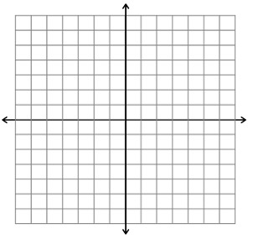

9.

