Law of Cosines Homework
Directions: Complete #1-6 on a separate sheet of paper using the Law of Cosines!

7. Mrs. Burge is planting a raspberry garden in the shape of a triangle to pay homage to her favorite subject in school. The side lengths are as follows: 50 feet, 60 feet, 100 feet. Mr. Giannini wants to find the measure of the largest angle. Help him!!!

8. Ms. Schmidt, who lives behind Mrs. Burge, is constructing a tomato garden. The garden will connect to the smallest side of the raspberry garden. An adjacent side is congruent to the smallest side of the raspberry garden. The third side is 72 feet. Ms. Labadie is laughing at their farming skills. Find the measure of the angle between the two congruent sides.

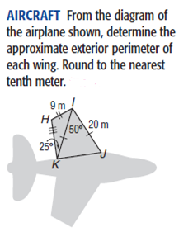
9.

110º

10. After the hurricane, the small tree in Mrs. Gross’ neighbor’s yard was leaning as she was hunkered down in her house. To keep it from falling, she nailed a 6-foot strap into the ground 4 feet from the base of the tree. She attached the strap to the tree 3 ½ feet above the ground. How far from vertical was the tree leaning?

