Law of Sines and Cosines HW #2
Directions: Solve for the variable. Round to the nearest tenth if needed.
1. Find a.
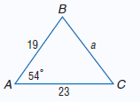

2. Find the measure of <C.
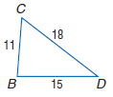

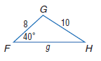
3. Solve for <H and g.

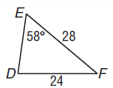
4. Find <D.

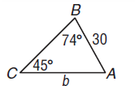
5. Find b.

6. Solve ∆DEF if, d=7, e=8, f=5

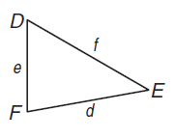

From Workbooks Study Guide pg 43 and 51.
Directions: Draw a triangle to go with each exercise and mark it with the given information.
Then solve the problem. Round angle measures to the nearest degree and side
measures to the nearest tenth.

1. One side of a triangular garden is 42.0 feet. The angles on each end of this side measure 66° and 82°. Find the length of fence needed to enclose the garden.

2. Two radar stations A and B are 32 miles apart. They locate an airplane X at the same time. The three points form <XAB, which measures 46°, and <XBA, which measures 52°. How far is the airplane from each station?

3. A civil engineer wants to determine the distances from points A and B to an inaccessible point C in a river. <BAC measures 67° and <ABC measures 52°. If points A and B are 82.0 feet apart, find the distance from C to each point.

4. A ranger tower at point A is 42 kilometers north of a ranger tower at point B. A fire at
point C is observed from both towers. If <BAC measures 43° and <ABC measures 68°,
which ranger tower is closer to the fire? How much closer?

Pg 51:
1. A triangular garden has dimensions 54 feet, 48 feet, and 62 feet. Find the angles at each corner of the garden.

2. A parallelogram has a 68° angle and sides 8 and 12. Find the lengths of the diagonals.

3. An airplane is sighted from two locations, and its position forms an acute triangle with
them. The distance to the airplane is 20 miles from one location with an angle of elevation 48.0°, and 40 miles from the other location with an angle of elevation of 21.8°. How far apart are the two locations?

4. A ranger tower at point A is directly north of a ranger tower at point B. A fire at point C is observed from both towers. The distance from the fire to tower A is 60 miles, and the distance from the fire to tower B is 50 miles. If m<ACB = 62, find the distance between the towers.

5. The angle of elevation from a point on the street to the top of a building is 29°. The angle of elevation from another point on the street, 50 feet farther away from the building, to the top of the building is 25°. To the nearest foot, how tall is the building?

