Name: _________________________ Hour: _________________

**Let’s Make a Date! Getting to know you!**

**Directions:** You will have five minutes to find a partner and “make a date”. You will write their name down on the line that says appointment with ____________. When your teacher tells you to, you will find a new date for the next “hour” (next question). The goal of this activity is to not only review Algebra and Geometry, but to meet people; ***so no repeating partners***!

**9:00 Appointment** with _____________________________________

a.) Solve the equation.

8x + 33 = -7(8 – 7x) + 7

Final Answer: ________________

b.) What cartoon character best describes you and why?

**10:00 Appointment** with _____________________________________

a.) Simplify the radical.

$\sqrt{1260}$

Final Answer: ________________

b.) Are you a morning or night person?

**11:00 Appointment** with ______________________________________

a.) Write an equation of a line that passes through (3, -5) and whose slope = -4

Final Answer: ________________

b.) Who do you respect the most and why?

**12:00 Appointment** with ______________________________________

a.) Find the slope between A(0, 5) and B(3,-2).

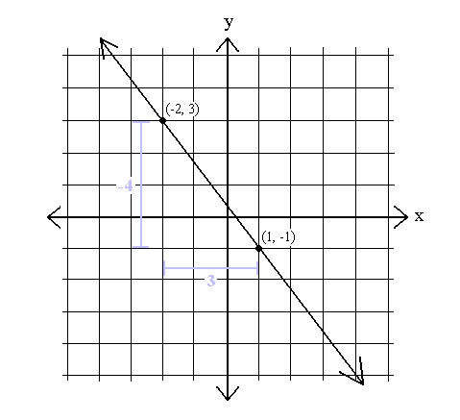

Final Answer: ________________

b.) What do you think you will be doing five years from now?

**1:00 Appointment** with ______________________________________

a.) Determine if line $\overset{⃡}{AB}$ from your noon appt is parallel, perpendicular, or neither with the line between C(-2,1) and D(5,4).



Final Answer: ________________

b.) What is one thing you treasure most?

**2:00 Appointment** with _______________________________________

a.) Solve for b using Pythagorean Theorem.



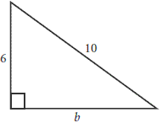

Final Answer: ________________

b.) What is your favorite subject in school? C’mon, you must have a favorite subject!

**3:00 Appointment** with _______________________________________

a.) Write the equation of the line that passes through (5, 1) and (8, -2)

Final Answer: ________________

b.) Do you have a graphing or scientific calculator?

**4:00 Appointment** with _______________________________________

a.) Solve the proportion.

$$\frac{5}{4}=\frac{y}{8}$$

Final Answer: ________________

b.) What is your favorite store?

**5:00 Appointment** with _______________________________________

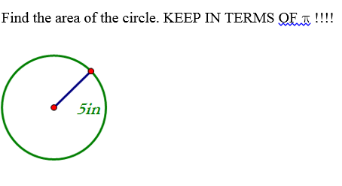a.)

Final Answer: ________________

b.) If you could pick one super power *that would help you in school*, what one super power would you choose? Why?