Linear Review

**Intro to Graphing Lines**

Label Quadrants in graph below: List the coordinates of the points plotted on the graph below.



A ________

B ________

C ________

D ________

[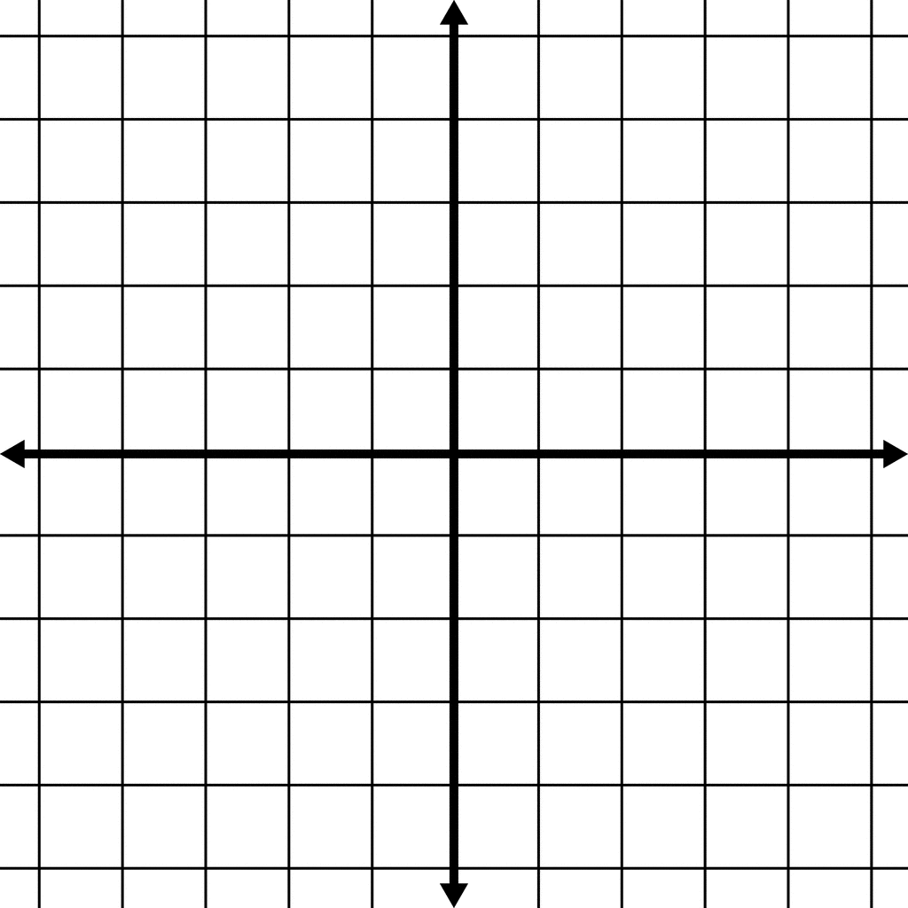](http://www.google.com/url?sa=i&rct=j&q=&esrc=s&source=images&cd=&cad=rja&uact=8&ved=0CAcQjRxqFQoTCKDj9IiOn8cCFYIFkgod498PKg&url=http%3A%2F%2Fetc.usf.edu%2Fclipart%2Fgalleries%2F648-coordinate-grids&ei=uejIVeCiMYKLyATjv7_QAg&bvm=bv.99804247,d.aWw&psig=AFQjCNGhkQNx66AI3N9IX4nRWuHsYqKKQA&ust=1439316531116293)

Change the scale on the grid to plot

(12,6) (-2,4) (-8,-4) (4,-10)

**Graphing an Equation:**

How to make a table…. Use a table of values to graph the equation: f(x) = 2x - 7



Make a table:

|  |  |
| --- | --- |
| x | f(x) |
|  |  |
|  |  |
|  |  |

Find 3 points that satisfy each equation then plot the line on the coordinate plane.



1. y = 3x – 2

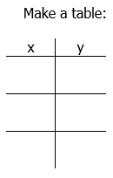



1. x + 4y = 4

Step 1: Solve for y. Steph 3: Graph

Step 2: Make a table





1. 2x – y = 3



**Slope-intercept form**

Slope-intercept form: $y=mx+b$ where m is the slope and b is the y-intercept



1. y = -3x -1



1. 5x – 3y = 15

Step 1: Solve for y. Step 2: Graph

1. -2x – 4y =12



**Graphing Lines by Intercept Method:**

1. Find the x-intercept by plugging in 0 for y.
2. Find the y-intercept by plugging in 0 for x.
3. Plot both points.
4. Construct the line.
5. -3x + 8y = 12 x-int _______ y-int _______



1. 4x + y = 6 x-int _______ y-int _______



Writing Linear Equations Review

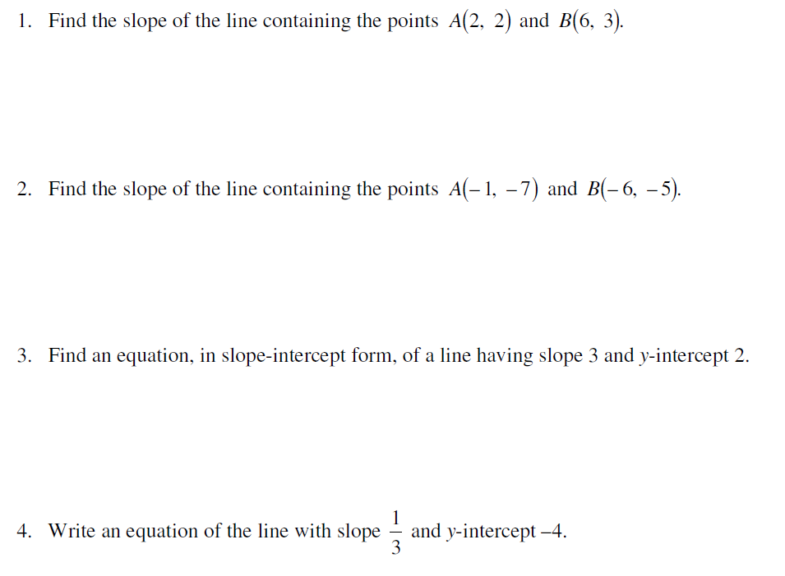

Use the formula:





$$m=\frac{y_{2}-y_{1}}{x_{2}-x_{1}}$$

Slope-intercept form: $y=mx+b$ where m is the slope and b is the y-intercept





Move all terms around so that y is alone.



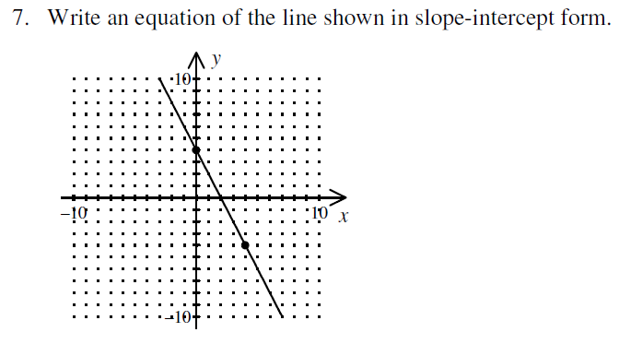

m = ______________

b = _______________

Now place into

y = mx + b

8. Write the equation of the vertical and horizontal lines that pass through the point

(7,-3)

***Recall that vertical means a line going straight up and down. This means it will always have the same x value no matter the y value. Graph the point, then graph the vertical line.

***Recall that horizontal means a line going right to left. This means it will always have the same y value no matter the x value. Graph the point, then graph the horizontal line.

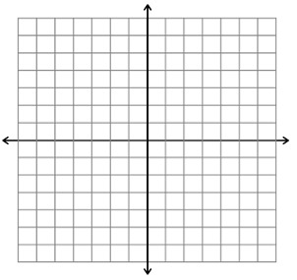



Use both slope intercept form and point slope form for practice.

$y=mx+b$ $y-y_{1}=m(x-x_{1})$

Plug in m, x, & y and solve for b. Plug in the point and slope!



For a slope to be undefined, it must be $\frac{Rise}{0}$.

For a slope to be zero, it must be $\frac{0}{run}$.



Hint- Try graphing it ☺





Hint- Try graphing it ☺

