Name: ___________________________________________________________________________
Making Conclusions: An Introduction to Proof Writing HW
Directions: Make a geometric conclusion based on the given information or diagram. You may need to draw a figure to visualize the concept prior to making a conclusion. Then use your justifications to explain the geometric conclusion.
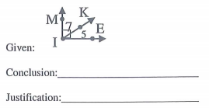
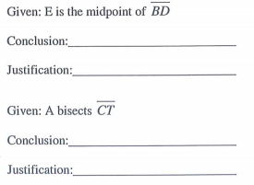
1. 7.

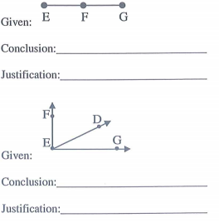
2.
8.

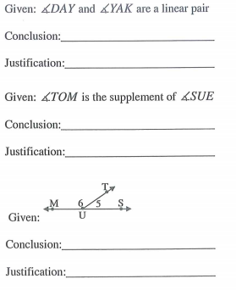
3.

9.
4.

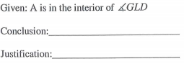
10.

5.
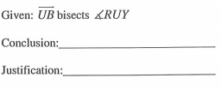
11.

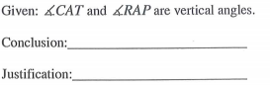
6.

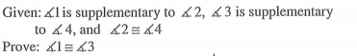
Directions: Fill in the correct justifications to make a logical argument.
12.

Statements: Reasons:
1. 1. _________________________
2. 2. _________________________

3. 3. _________________________
4. 4. _________________________
5. 5. _________________________

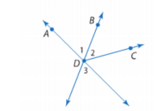

13. Given: $\vec{DB} is an angle bisector of<ADC$
Prove: <2$≅$<3

Statements: Reasons:
1. $\vec{DB} is an angle$ 1. __________________
$$bisector of<ADC$$
2. <2$≅$<1 2. __________________
3. <1$≅$<3 3. __________________
4. <2$≅$<3 4. __________________

Name: ___________________________________________________________________________
Making Conclusions: An Introduction to Proof Writing Notes
Directions: Make a geometric conclusion based on the given information or diagram. You may need to draw a figure to visualize the concept prior to making a conclusion. Then use your justifications to explain the geometric conclusion.
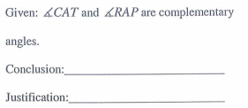
1.

2.

3.

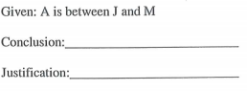
4.

Proof Notes
Proof: A mathematical argument or explanation that begins with known facts, uses definitions, axioms, postulates, theorems to arrive at a conclusion about a geometric statement.
Steps to writing a two-column proof:
- First state the given.
- What can you conclude from the given?
- What can you conclude from the diagram?
- Redecorate & Reason
- End with what you wanted to prove.
- Double check logic and make sure your steps are numbered.
Skeleton Proof: Fill in the blank proof.
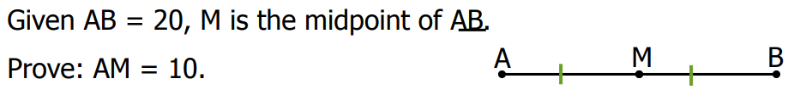
5.

Statements: Reasons:
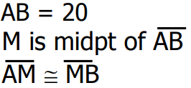
1. 1. _________________________
2. 2. _________________________
3. 3. _________________________
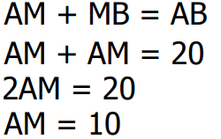
4. 4. _________________________
5. 5. _________________________
6. 6. _________________________
7. 7. _________________________
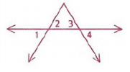

6. Given: <2$≅$<3
Prove: <1$≅$<4
Statements: Reasons:
1. <2$≅$<3 1.
2. <2$≅$<1 2.
3. <4$≅$<3 3.
4. <1$≅$<4 4.

