Name: _______________________________________________________
Median Notes
A cardboard triangle will balance on the end of a pencil if the pencil is placed on a particular point on the triangle. This point is call the MEDIAN OF A TRIANGLE. The median of a triangle is the segment from a vertex to the midpoint of the opposite side.
The point where all three medians intersect is called the CENTROID. This will be the balancing point of the triangle.

Examples of Medians: Example of Centroid:
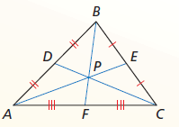
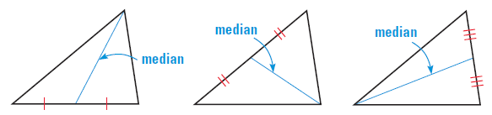
z

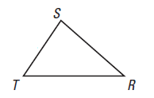
Ex. 1) In the following triangle, draw a median.
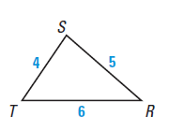

Ex. 2) NC is the median of ∆ABC. Find x if $NA = 4x – 1$ and $NB = 3x + 2.$

Ex. 3) RK is the median of ∆IJK. Find x if $JI= x - 2$ and $RI = x - 7$

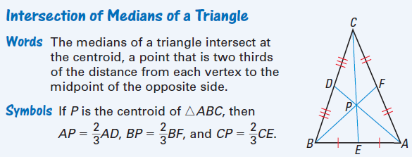

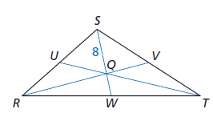
Ex. 4) Q is the centroid of ∆RST. If $SQ=8$, find QW and WS.

Ex. 5) If P is the centroid of ∆MNL and QN = 21in, find NP and PQ.
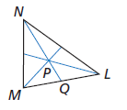

Ex. 6) If D is the centroid of ∆ABC and ED = 18 ft , find DC and EC.
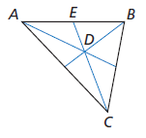

Ex. 7) If Z is the centroid of ∆HIJ where $JR=5x+4$ and $ZR=2x$, find JZ.

Name: _______________________________________________________
Median HOMEWORK
A cardboard triangle will balance on the end of a pencil if the pencil is placed on a particular point on the triangle. This point is call the MEDIAN OF A TRIANGLE. The median of a triangle is the segment from a vertex to the midpoint of the opposite side.
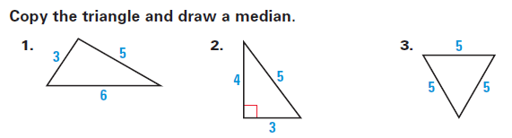

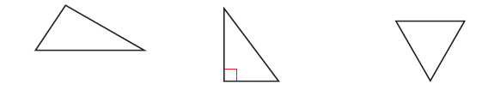

4. 5. 6.

7. 8.

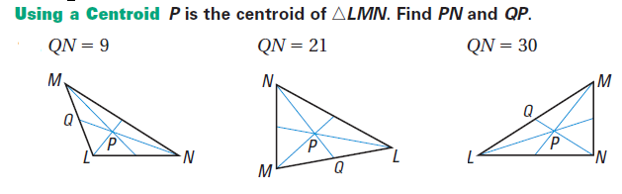

9. 10. 11.

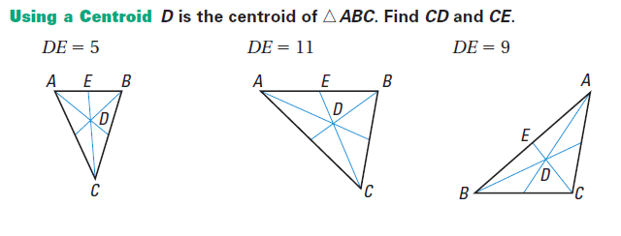

12. 13. 14.

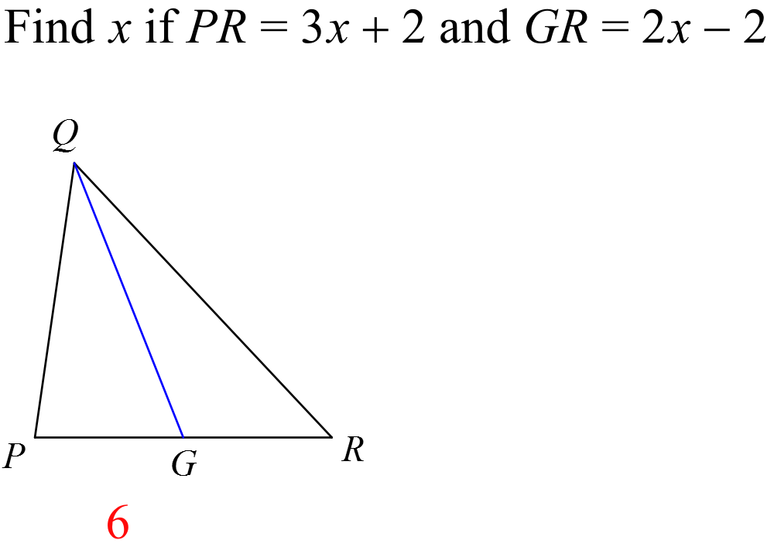
15.

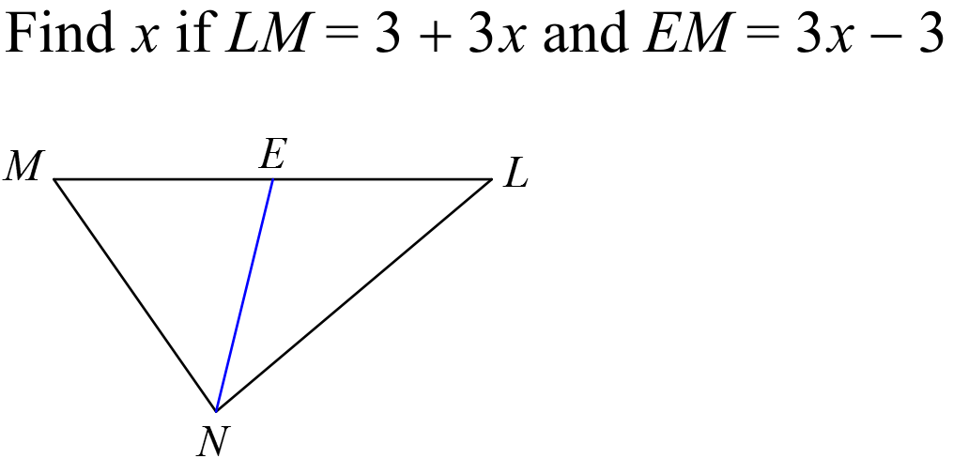
16.

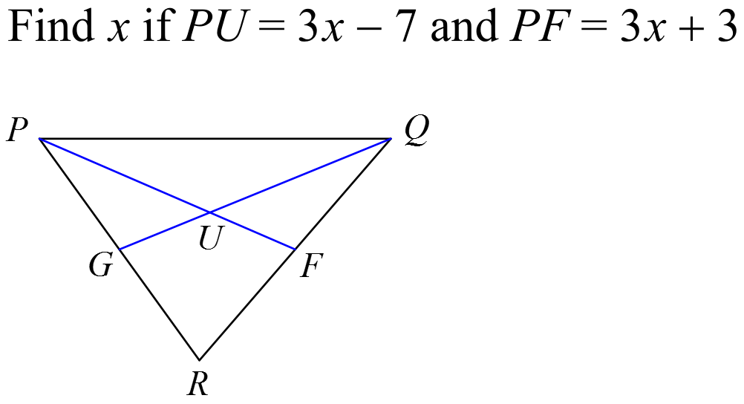
17.

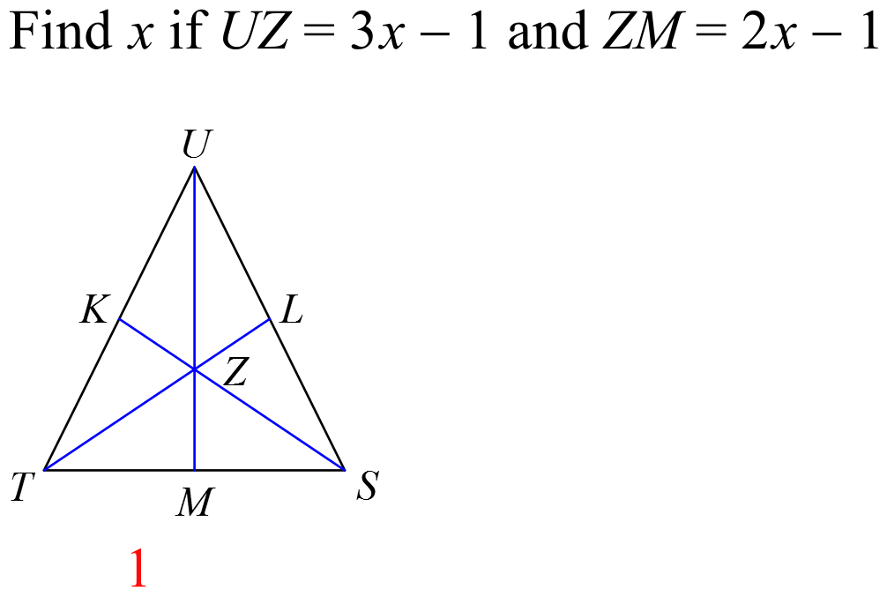
18.

