Homework – Midsegments Name: _________________________________

$\overline{DE}$ is the midsegment of $∆ABC$. Find the value of x.
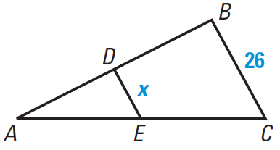 | 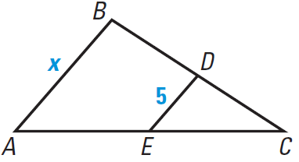 | 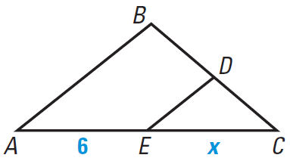
In $∆XYZ$, $\overline{XJ}≅\overline{JY}$, $\overline{YL}≅\overline{LZ}$, and $\overline{XK}≅\overline{KZ}.$ Complete each statement.

- $\overline{JK}∥$ _____ | - $\overline{JL}∥$ _____
- $\overline{XY}∥$ _____ | - $\overline{YJ}≅_________ ≅_________$ | 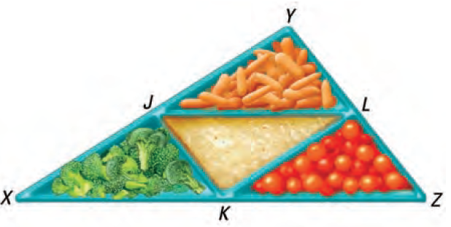
- $\overline{JL}≅_________ ≅_________$ | - $\overline{JK}≅_________ ≅_________$

Prior Knowledge and Making Connections – Use the diagram to complete the statements and provide a reason (angle relationship).

- $∠G≅∠BAH$ because:

_______________________________________
- $∠J+∠ABJ=180°$ because:  _______________________________________ | 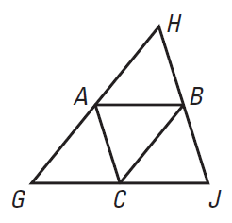
- $∠JCB≅∠CBA$ because:

_______________________________________
- $∠J+∠G+∠H=180°$ because:

_______________________________________

Use $∆GHJ$, where A, B, and C are midpoints of the sides.
- If $AB=3x+8$ and$GJ=2x+24$, what is AB?
- If $AC=3y-5$ and $HJ=4y+2$, what is HB?
- If $GH=7z-1$ and $BC=4z-3$, what is GH?

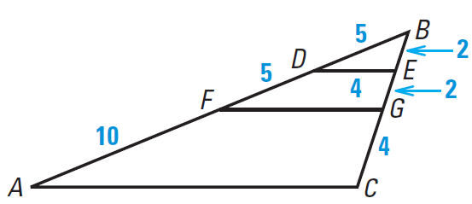
- $\overline{DE}$ is the midsegment of which triangle?
- What are the midpoints of $\overline{AB}$ and $\overline{BC}$?

- What is the length of $\overline{AC}$?

