Notes – Midsegments | Name:
Standard: | Hour:

Objective: I know what a midsegment of a triangle is and its properties related to parallel segments and length.

Definition
A _________________________ connects the midpoints of 2 sides of a polygon. Every triangle has 3 midsegments.

Examples
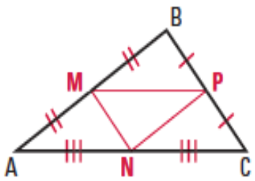 | - Name the 3 midsegments | - List the congruent segments

Theorem
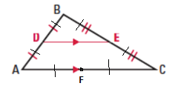
A midsegment of a triangle is _____________________ to the third side and ___________ the length of the third side.

Examples
Use the diagram in the theorem box. Assume F to be the midpoint of segment AC.
- Write the 3 parallel statements using each midsegment. |  | - Complete each congruence statement.  $$\overline{DE}≅_________≅__________$$  $$\overline{FE}≅_________≅__________$$  $$\overline{DF}≅_________≅__________$$
$\overline{DE}$ is the midsegment of $∆ABC$. Find the value of x.
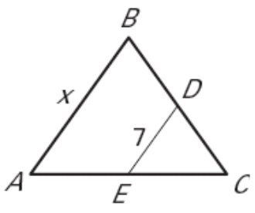 | 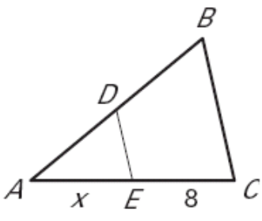 |  | 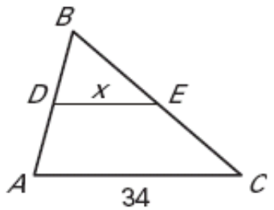

Practice
Use the diagram for the next 4 problems. D, E, and F are midpoints.
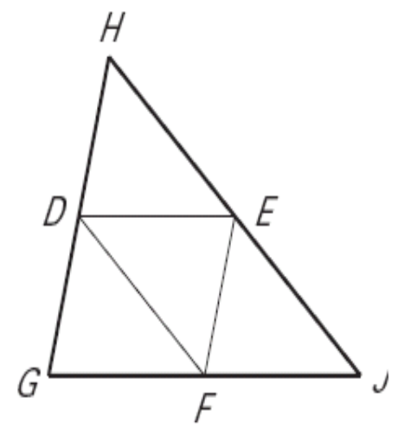 | - If $DE=4x+5$ and $GJ=3x+25$, find DE
 | - If $EF=2x+7$ and $GH=5x-1$, find EF.
- If $HJ=8x-2$ and $DF=2x+11$, find HE. | - If $HD=3x+29$ and $DG=14x+7$, find EF.

