Quadrilaterals and Special Parallelograms HW

Classifying: Classify all that apply (quadrilateral, parallelogram, rhombus, rectangle, square)
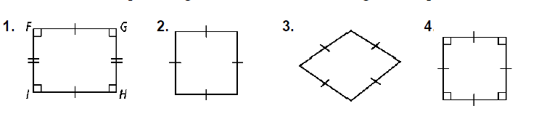

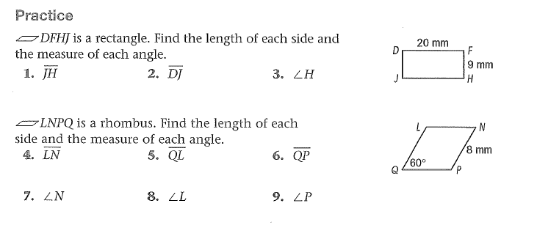

Determine if the figures are parallelograms, by definition.

10.
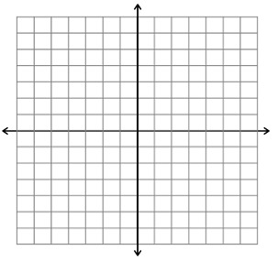

11.

