Practice Examples: Parallelogram Properties HW DAY 2

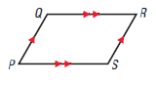



**Parallelogram −**

**Notation:**

**Properties of Parallelograms:**

If a quadrilateral is a parallelogram, then…

**1.**

**2.**

**3.**

**4.**

**5.**

Make sure you justify your set up (your properties)!

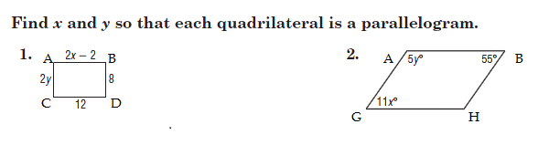

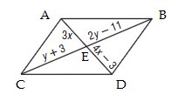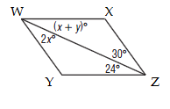

3. 4.

A B A B

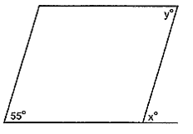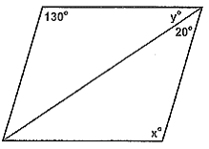

5. 6.

D C D C

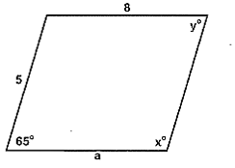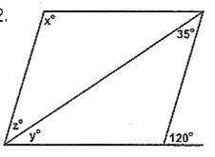

7. A B 8. K L

D C N M

20

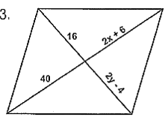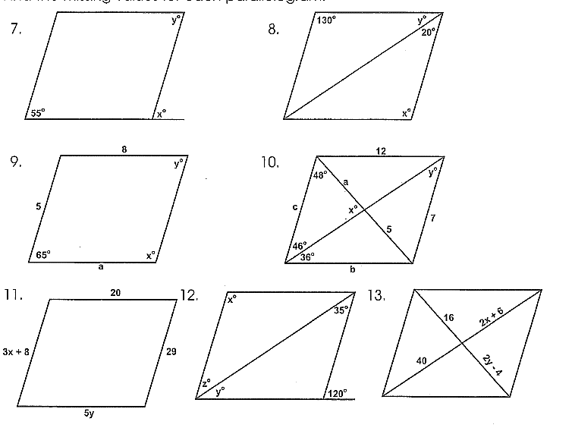 F G M N

9. 10.

L H P Q

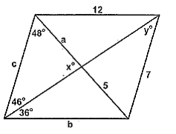

11. M N

.

Q P