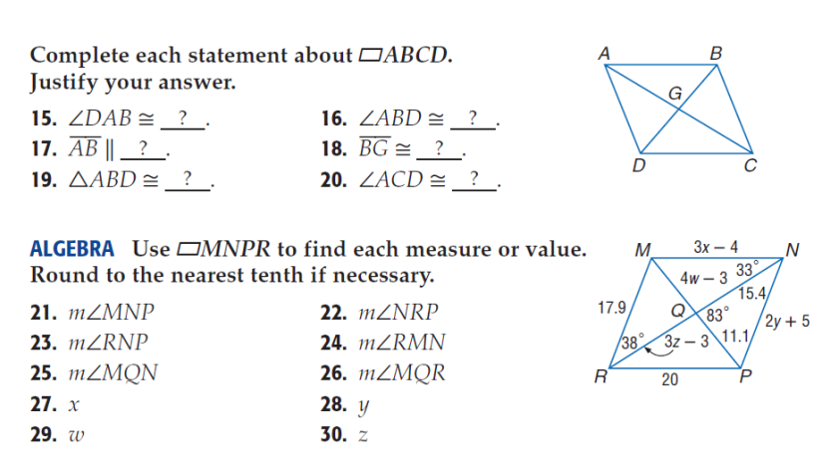**Acc: Parallelograms and Special Parallelograms Practice**

Pg 329

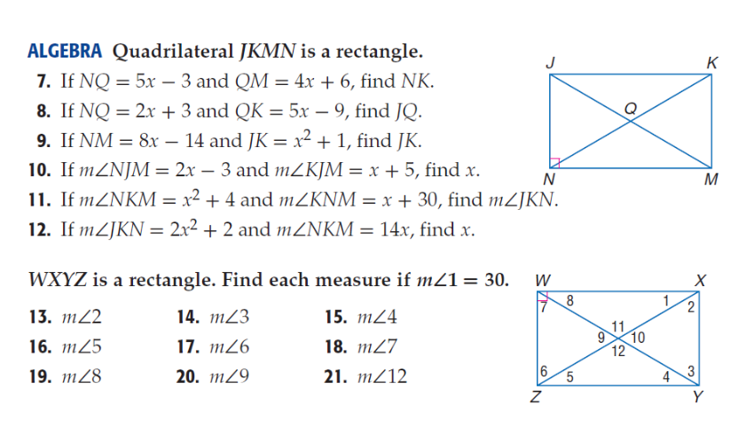

Pg 345

















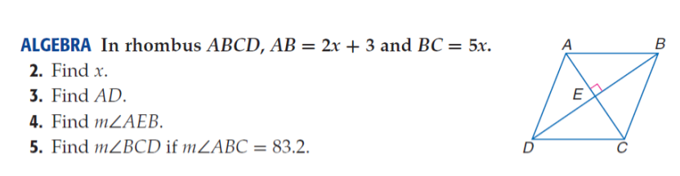

Pg 351

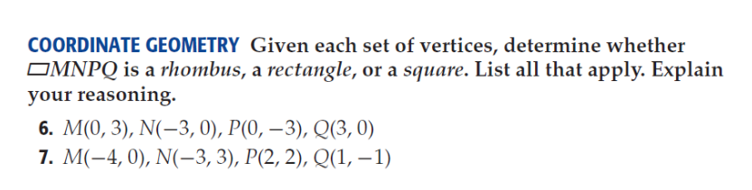**Complete the following on a separate paper and show all of your work!**

