Name: _____________________________________________________________________________

Parallels Cut by a Transversal HW Day 2

Directions: Find the value of the variable, show your geometric set up, and justify your set up!
You must use only the following relationships:
Corresponding angles are congruent
Alternate interior angles are congruent
Alternate exterior angles are congruent
Consecutive interior angles are supplementary
Linear pairs are supplementary
Vertical angles are congruent
Solve for x.
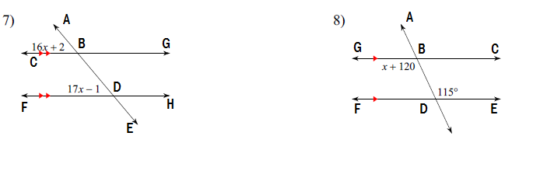

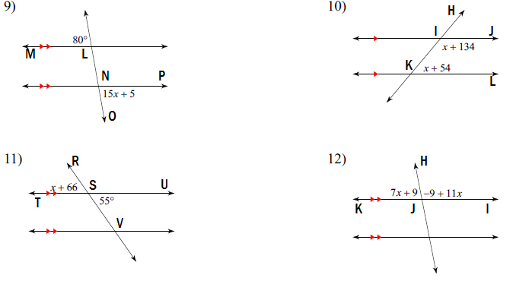

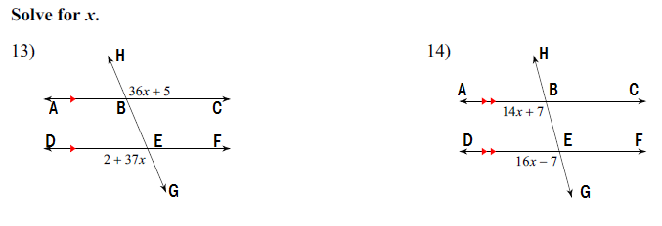

Just solve for x and justify. No geometry.
