Name: ____________________________________________________________________ HR:_______________
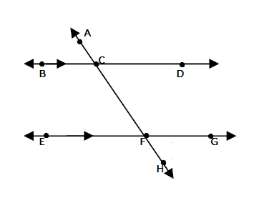
Parallels cut by a Transversal Practice QUIZ
Directions: Find the value of the variable, show your geometry and justification for each.

1.

12x-3

105ᵒ

x= ___________________
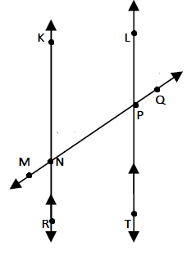
2.

-6+12x

11x

x= ___________________
3.

7x+18

6x+19

x= ___________________

4.

53x-1
38x-1

x= ___________________
Directions: Find the value of the variable and the measure of the angle, show your geometry and justification for each.
5.

22x+7

24x-1

x= _______________________

m<BCF = _______________
6.

15x+5 14x+12

x= ___________________
m< TPQ = _______________

