Name: _________________________________________________ Date: __________ Hr:____________
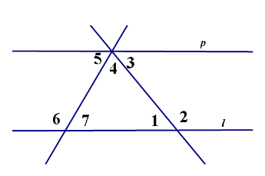
Parallels Cut by Transversals Proofs Assignment

1. Given: <7≅<1 and l // p
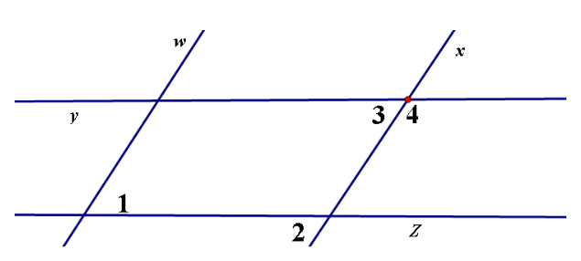
Prove: <5≅<3

2. Given: w // x and y // z
Prove: <1 and <4 are supplementary

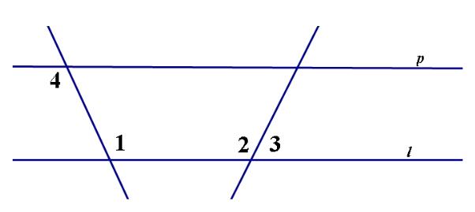
3. Given: <1≅<2 and l // p
Prove: <3 + <4 = 180°

