Name: _________________________________________________ Date: __________ Hr:____________
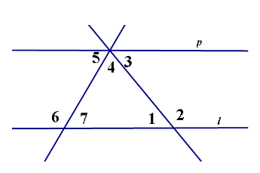
Parallels Cut by Transversals Proofs HW

1. Given: <7≅<1 and l // p
Prove: <5≅<3

1. <7≅<1 and l // p 1. Given
2. <7≅<5, <3≅<1 2. __________________
3. ______________ 3. Substitution
4. <5≅<3 4. _________________

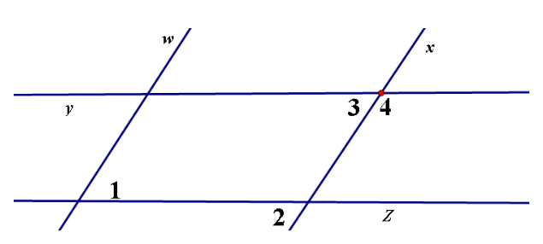

2. Given: w // x and y // z
Prove: <1 and <4 are supplementary

1. w // x and y // z 1. ______________________
2. <1≅<2 2. ______________________
3. <2≅<3 3. ______________________
4. <3 + <4 = 180 4. ______________________
5. <2 + <4 = 180 5. ______________________
6. <1 + <4 = 180 6. ______________________
7. <1 and <4 are 7. ______________________
supplementary
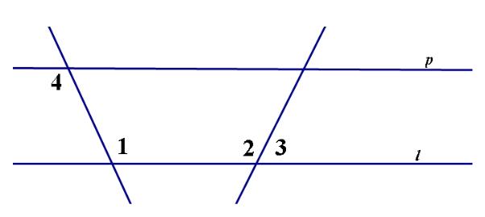
3. Given: <1≅<2 and l // p
Prove: <3 + <4 = 180°

1. <1≅<2 and l // p 1. ______________________
2.___________________ 2. ______________________
3. ___________________ 3. ______________________
4.____________________ 4. ______________________
5. <3 + <4 = 180° 5. ______________________

