3. a). Sketch the graphs of ${y=\sin\left(θ-{60}^{o}\right), y=\sin{(θ}}+{90}^{o})$using different colors and label the graph with the equation.

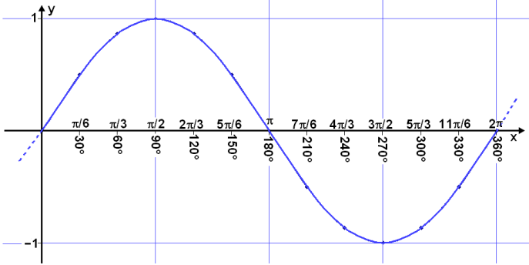

b). Describe the transformations that occurred using -60 and 90.

This transformation is called a phase shift.

These transformations hold true for both the cosine and tangent functions as well. To summarize

Steps to graphing without a calculator:
- Graph the new midline, max line and minimum if applicable.
- Determine the period.
- Apply any phase shifts & graph following the patterns of the parent function.
Sine = midline, max, midline, minimum, midline
Cosine = max, midline, minimum, midline, max
Tangent = midline, asymptote, midline

