Name: ____________________________________________________________________________
Polygon Warm-up 6.1-6.4
Assume all polygons are regular.
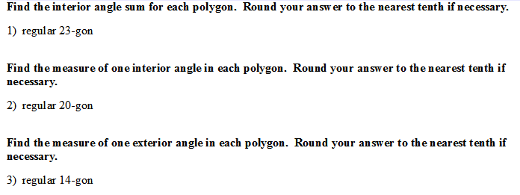

4.) Find the sum of exterior angle measures of a 43-gon.

5.) Find the number of sides a regular polygon has if the measure of an interior angle is 135ᵒ.

6.) Circle all of the properties that hold true for a parallelogram.
Opposite angles are = opposite sides are // opposite side are = diagonals bisect the angles
Diagonals bisect each other Diagonals are congruent diagonals are $⊥$ Sides are $⊥$
One pair of // sides Consecutive interior angles are suppl.

7.) Solve through factoring: 8.) Solve through factoring:
$x^{2}+9=2x+44$ $x^{2}-1=3x+9$

Key
1. 3780
2. 162
3. 25.7
4. 360
5. 8 sides
6. Opposite angles are = opposite sides are // opposite side are =
Diagonals bisect each other Consecutive interior angles are suppl.
7. x= 7 or x=-5
8. x=5 or x=-2

