Acc Geo Name__________________________
Practice 2.8 Day #1

Write a two-column proof for each of the following.

1. Theorem: If two angles are supplementary to the same angle then they are congruent.
Given: $∠3$ and $∠4$ are supplementary; $∠3$ and $∠5$ are supplementary
Prove: $∠4≅∠5$

2. Given: $m∠3={120}^{o}$; $∠1≅∠4$; $∠3≅∠4$
Prove: $m∠1={120}^{o}$

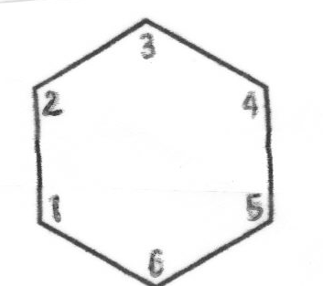

Write a two column proof for the following.

3. Given: $∠QVW$ and $∠RWV$ are supplementary
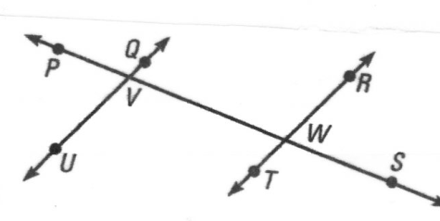
Prove: $∠QVP≅∠RWV$

4. Given: $∠5≅∠6$
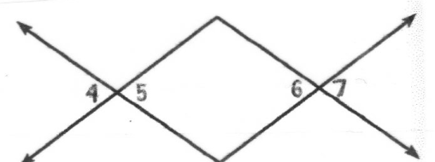
Prove: $∠4≅∠7$

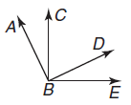
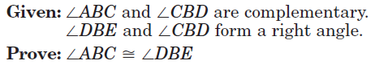
5.

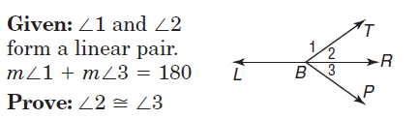
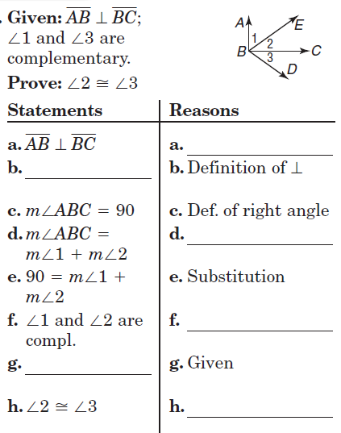
6. 7.

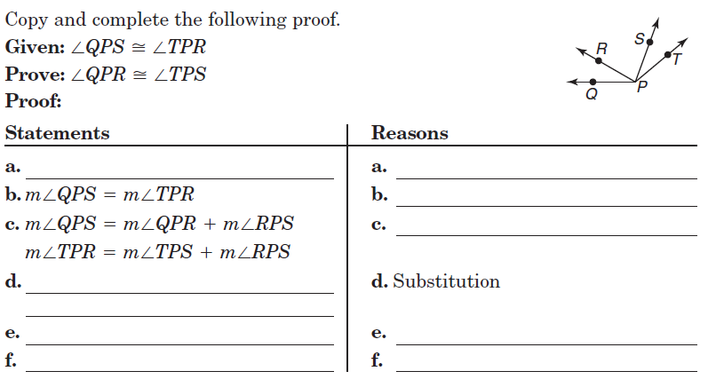
8.

