**Acc Geo Name__________________________**

**Practice 2.7 and 2.8 Again ☺**

**Write a two-column proof for each of the following.**

1. Theorem: If two angles are supplementary to the same angle then they are congruent.

**Given: $∠3$** and $∠4$ are supplementary; $∠3$ and $∠5$ are supplementary

**Prove:**

2. Given: ; ;

Prove: $m∠1={120}^{o}$

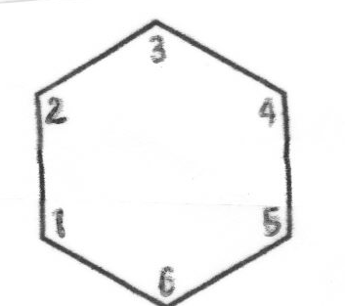

**Write a two column proof for the following.**

3. Given: and are supplementary

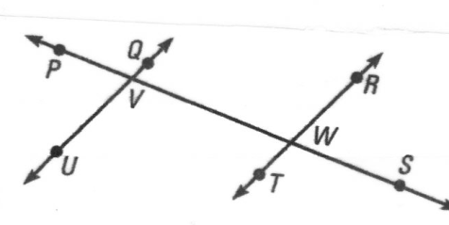 Prove:

4. Given:

Prove:

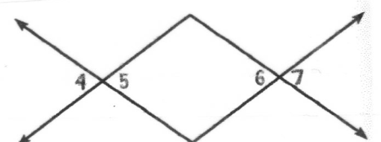

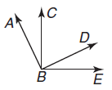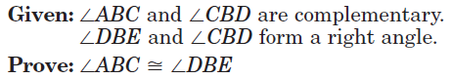5.

6. Given: 

Prove: 



7. Given: and $∠1$ and $∠3$ are complementary

Prove: $∠2≅∠3$

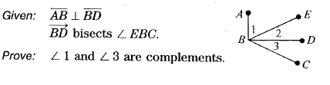

8.

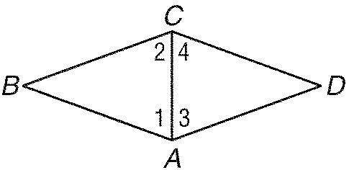9.

**Given:** *AC* bisects *BAD*.

*AC* bisects *BCD*.

1  2

**Prove:** 3  4

10. 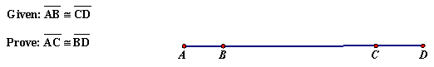

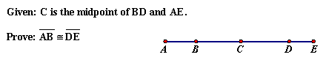

11.