Proving Angle Relationships and Parallel Lines: Notes

Example 1:
Use Alternate Exterior Angles to prove Alternate Interior Angles are Congruent.
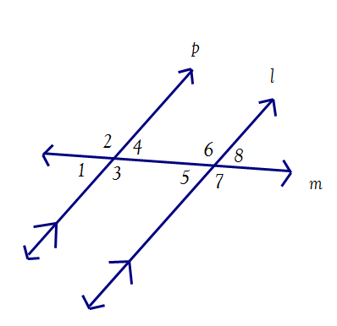
Given:
p//$l, <1≅<8$
Prove: $<4≅<5$

Example 2.
Prove Consecutive Interior Angles are supplementary.
Given: p//$l, <1≅<8$
Prove: $<3 and <5 are supplementary$

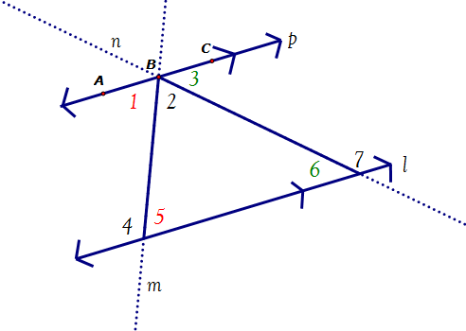
Example 3:
Prove the Triangle Sum Theorem
(don’t use it in the proof)
Given:
p//$l$Prove:
$$m<5+m<2+m<6=180$$

Corresponding Angles Converse Postulate:

- If corresponding angles are ___________________ then the lines are _______________________.

Proof of the Alternate Exterior Angles Converse Theorem:

- If alternate exterior angles are ___________________ then the lines are _______________________..
1
2
3
c
d
Given: $∠1≅∠2$
Prove: c$∥d$

Proof of:
- If two lines are _______________________ to the same line, then they are __________________.
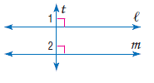
Given: $l⊥t and m⊥t$
Prove: $l ∥m$

List of Justifications Up To Chapter 3

Vertical angles are ________ Linear pairs are _________

_______ lines form _______ Consecutive interior angles

_______ lines form _______ Corresponding angles

_______ lines form _______ Alternate interior angles

_______ lines form _______ Alternate exterior angles

____ Corresponding angles form _____ lines

____ Consecutive interior angles form _____ lines

____ Alternate Interior angles form _____ lines

____ Alternate Exterior angles form _____ lines

Def of ⊥ Def of Compl Def of Suppl. Def of < bisector

Angle addition Segment addition Def of Midpoint

Substitution Def. right angle

Angle addition (straight angle) Triangle Sum Theorem

Proving Angle Relationships and Parallel Lines:
In Class Practice
1. Given: <7≅<1 and l // p
Prove: <5≅<3

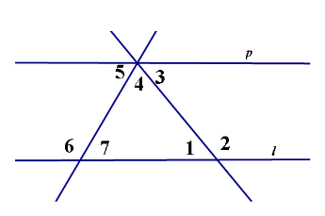

2. Given: <1 and <3 are supplementary
Prove: y || a

3. Proof of the Consecutive Interior Angles Converse Theorem:

- If consecutive interior angles are ___________________ then the lines are _______________________.
1
2
3
c
d
Given: $∠1 \& ∠2 are supplementary$
Prove: c$∥d$

Proving Angle Relationships and Parallel Lines:
Homework
1. Use Alternate Exterior Angles to prove Corresponding Angles are Congruent.
Given: p//$l, <1≅<8$

Prove: $<2≅<6$

Proof of the Alternate Interior Angles Converse Theorem:

- If alternate interior angles are ___________________ then the lines are _______________________.
1
2
3
c
d
Given: $∠1≅∠2$
Prove: c$∥d$

3. Given: w // x and y // z
Prove: <1 and <4 are supplementary
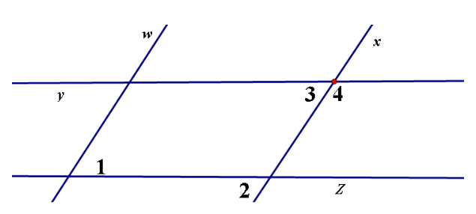

4. Given: <1≅<2 and l // p
Prove: <3 + <4 = 180°
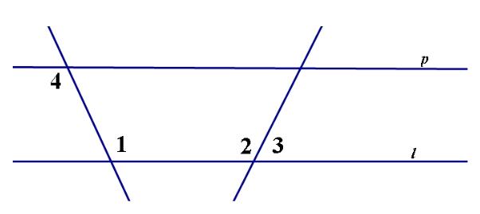

5. Given: and
Prove:
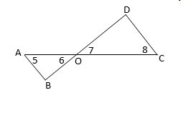

6. Given: and //
Prove:
