Name: __________________________________________________________________________
Putting it All Together! Homework #1 2019

Directions: If it is not indicated, round to the nearest thousandth.
1. Find the volume and surface area.
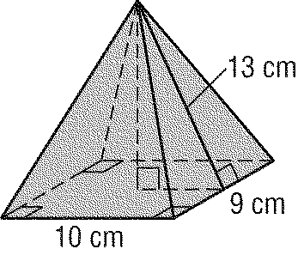

2. The volume of the rectangular pyramid has a volume of about 266.67 yd³. The base of the pyramid is a rectangle that is 10 yd by 8 yd. Find the height of the pyramid.
h

3. The volume of a cylinder is 7875 cubic meters and the radius is 15 meters. Find the height the cylinder.

4. The volume of a rectangular pyramid is 84 in³ and the area of the base is 12 in². Find the height of the pyramid.

5. The surface area of a cone is 250 km². The cone has a diameter of 20 km. Find the slant height of the cone.

6. Find the surface area and volume of the composite solid.

7. Find the surface area and volume of the composite solid.

8.

9.

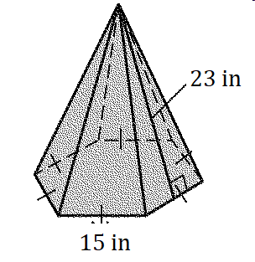
10. Find the surface area.

