Name: __________________________________________________________________________
Putting it All Together! Day 1 In-Class
1.

2. Find the surface area and volume of the following figure.

Examples: Find the missing dimension. Round to the nearest tenth.
3. The volume of a triangular prism is 96m³. The prism has a right triangle base with legs of 8 meters and 6 meters. Find the height of the prism.

h

4. The volume of the rectangular pyramid has a volume of about 146.67 km³. The base of the pyramid is a rectangle that is 5 km by 8 km. Find the height of the pyramid.
h

5. The volume of a cylinder is 616 cubic meters and the height is 4 meters. Find the length of the diameter of the cylinder.

6. The volume of a rectangular prism is 1152 cubic inches and the area of the base is 64 square inches. Find the height of the prism.

7. The surface area of a cone is 261.9 km². The cone has a diameter of 18 km. Find the slant height of the cone.

8. The surface area of the trapezoidal prism is 489.6 mi². Find the missing length below.

h

9.

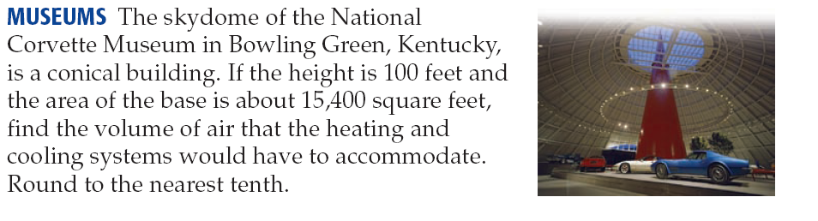
10.

