Name: ______________________________________________________________ Date: _____________ HR: ________
Pythagorean, Distance and Midpoint Review

Find $x.$
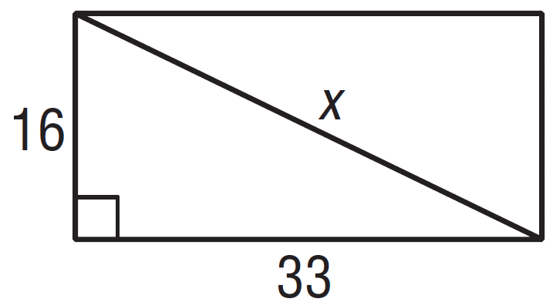

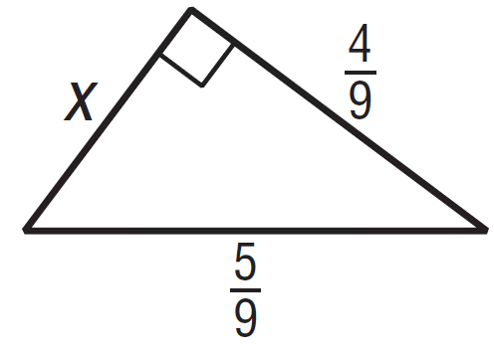
2)

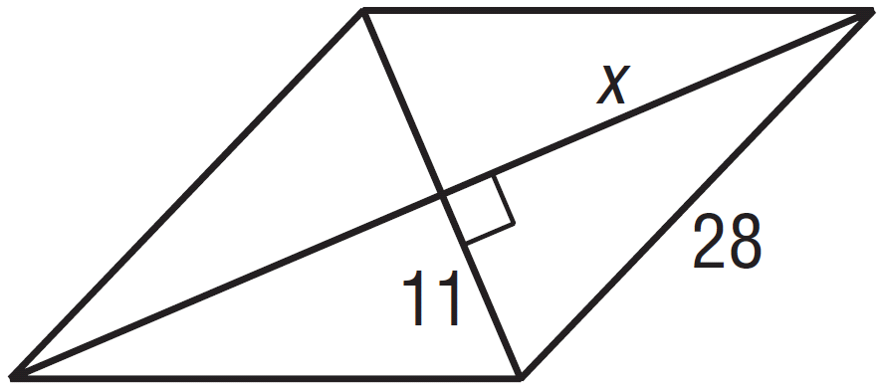
3)

Directions: Use the Pythagorean Theorem or Distance Formula to find the distance of each segment, and then find the midpoint of each segment. You must simplify radicals and fractions!!!!

4) G(2,6), H(-1,4) Distance: __________

Midpoint:___________

Slope: _____________

Directions: M is the midpoint of $\overline{XY}$. Find the missing endpoint’s coordinates based on the given information.

5) M(2,3), X(-1,5) Find Y(x,y)

6) M(3,1), Y(-4,7) Find X(x,y).

Use figure to the left for 7-9.
In this figure,$\overline{GE}$ bisects $\overline{BC}$ and $\overline{GF}$ bisects $\overline{AB}$. $\overline{FG}⊥\overline{GE}.$

7. Find the coordinates of F, E and G. F: ______
E: _______

G: _______

8. Find the following lengths by calculating the distance between each endpoint.

AB=___________ BE=___________

BC=___________ BF=___________

CD=___________ BG=___________

BD=___________ DG=___________

9. Name conclusions or relationships that you can conclude based on the information you found in #7 and #8. It must be based on what YOU found, NOT what was given to you.

