Name: _________________________Date: _________________Hour: _________

Pythagorean Theorem & Visual Proofs

Review:
What is the Pythagorean Theorem? ____________________________________

What do you use the Pythagorean Theorem for? __________________________

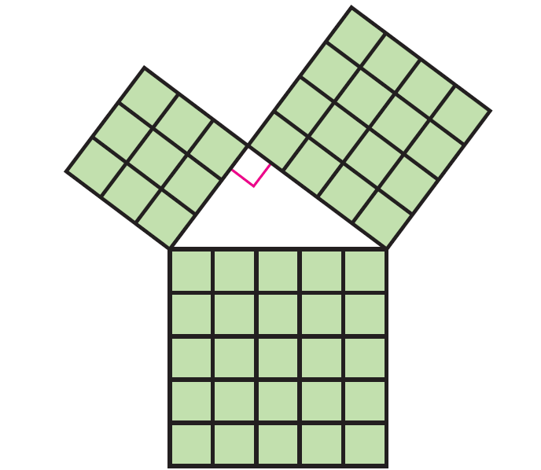

Name: ___________________________________________________
Choose one to prove.
Algebraic Proofs of the Pythagorean Theorem

1. Using the diagram, write two different expressions that represent The Pythagorean theorem. Algebraically manipulate the equation to prove the Pythagorean Theorem. Be sure explain the set up of your proof.

2. Using the diagram, write two different expressions that represent The Pythagorean theorem. Algebraically manipulate the equation to prove the Pythagorean Theorem. Be sure to explain the set up of your proof.

Pythagorean Theorem In-class Practice
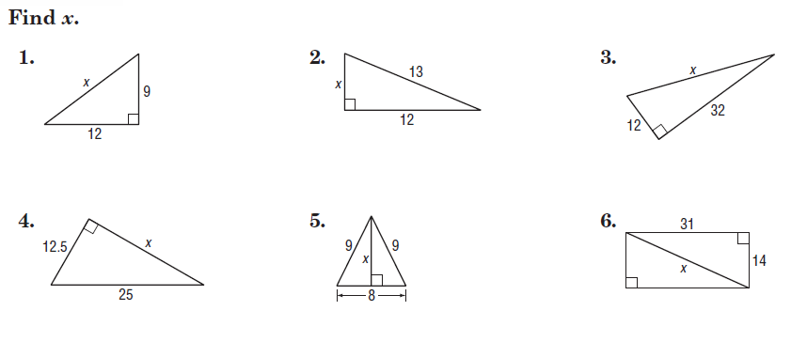
Find x and simplify ALL radicals.

